# **S.3 CHEMISTRY NOTES**

**MOLE CONCEPT**

## **Introduction**

Mole concept deals with determining or counting the number of particles. Since the number of particles is in large quantities, it becomes very difficult to deal with large numbers; therefore, these particles are placed in groups called moles. One mole of a substance has 6.02×1023 particles. The particles of substances grouped into moles can be molecules, atoms, ions, electrons, radicals, protons or any other specified particles. For example 1 mole of magnesium atoms contains 6.02×1023 atoms, 1 mole of magnesium ions contains 6.02×1023 ions, 1 mole of H2SO4(aq) molecules contains 6.02×1023 molecules of H2SO4(aq).

A **mole** is the amount of substance which contains 6.02×1023 particles. Or

A mole is the amount of substance that contains the same number of particles as the number of particles in 12grams of carbon-12.

The number 6.02×1023 is called Avogadro‘s number or constant and it is denoted by letter L.

**Molar Mass**

Molar mass is the mass of one mole of a substance. It is equal to the relative atomic mass expressed in grams. The relative atomic masses of all elements have already been established. Examples are given below.

**Formula mass or molecular mass**

This is the mass of one mole of a compound. It is obtained by adding the relative atomic masses of the atoms present in a compound. The formula mass of a compound is equal to the relative formula mass expressed in grams.

***Examples***

Calculate the formula masses of the following compounds.

=(1x2) + 16

=18g

=2x16

=32g

1. Water ,H2O (H=1,O=16)
2. Oxygen molecule, O2 (0=16)
3. Sodium sulphate, Na2SO4 (Na=23,S=32,0=16)

=(2x23)+32+(4x16)

=46+32+64

=142g

1. Copper (II) sulphate crystals, CuSO4.5H2O (Cu=64,S=32,O=16,H=1)

=64+32+(4x16)+5(2x1+16)

=250g

***Exercise***

Calculate the relative formula masses of the following compounds.

1. FeSO4.7H2O (Fe=56,S=32,O=16,H=1)
2. (NH4)2SO4 (N=14,H=1,S=32,O=16)
3. Al2O3 (Al=27,O=16)
4. Ca(HCO3)2 (Ca=40,H=1,C=12,O=16)

**Calculating number of particles**

This is based on the relationship that one mole of a substance contains 6.02×1023 particles.

***Examples***

1. Calculate the number of particles in the following compounds.
   1. Water (H2O)

Number of molecules in 1 mole of H20 = 6.02×1023 molecules

1mole of H2O contains 2 moles of H atoms, therefore, number of H atoms in 1 mole of H2O = (2X6.02×1023) =12.04x1023 atoms.

Number of O atoms in 1 mole of H2O =6.02×1023.

* 1. 2 moles of oxygen molecules,(2O2)
     1. mole of oxygen molecules contains 6.02×1023 molecules
     2. moles of oxygen molecules contains (2x6.02×1023)= 12.04x1023 molecules

1. mole of oxygen molecule contains 2 moles of oxygen atoms
2. moles of oxygen molecules contains (2x2)= 4 moles of oxygen atoms 1 mole of oxygen atom contains 6.02×1023 atoms

4 moles of oxygen atoms contains (4x6.02×1023)= 24.08x1023 atoms.

* 1. Number of hydrogen ions in 2 mole of H2SO4
     1. mole of H2SO4 contains 2 moles of H+
     2. moles of H2SO4 contains (2x2)= 4 moles of H+ 1 mole of H+ contains 6.02×1023 ions

4 moles of H+ contains (4x6.02×1023)= 24.08x1023 H+ ions

* 1. Total number of ions in 1 mole of (NH4)2SO4

(NH4)2SO4(aq) 2(aq) + (aq)

1 mole of (NH4)2SO4 contains 3 moles of ions 1 mole of ion contains 6.02×1023 ions

3 moles of ions contains (3x6.02×1023)= 18.06x1023 ions

1. Calculate the number of atoms in the following
2. 0.25 moles of calcium

1 mole of calcium contains 6.02×1023 atoms

0.25 moles of calcium contains () atoms

=1.5x1023 atoms

1. 8 moles of sulphur

1 mole of sulphur contains 6.02×1023 atoms

8 moles of sulphur contains () atoms

=4.8x1023 atoms

1. O.4 g of oxygen atoms

1 mole of oxygen atom contains 6.02×1023 atoms g of oxygen contains 6.02×1023 atoms

g of oxygen contains () atoms

.4g of oxygen contains () atoms

=1.5 x 1024 atoms

***Exercise***

* 1. Calculate the following (Al=27,H=1,O=16,S=32,Ca=40,Na=23,Hg=201,Cl=35.5)
     1. Number of atoms in 2 moles of sodium
     2. Number of molecules in 5 moles of hydrogen (H2)
     3. Number of ions in 1 mole of Al2(SO4)3
     4. Number of hydroxyl ions in 2 moles of Ca(OH)2
  2. Calculate the number of particles in the following
     1. 0.1 moles of sodium atoms
     2. 0.5 moles of chlorine atoms
     3. O.3 moles of calcium atoms

1. Use the value of 6.02×1023 mol-1 for the Avogadro constant to find the number of atoms in
   1. 2.0x 10-3g of calcium
   2. 5.0x10-6g of argon
   3. 1.00x10-10g of mercury

**Converting number of particles to masses**

***Example***

1. Calculate the mass of sodium with 1.5x1022 sodium atoms. (Na=23, L=6.02×1023 atoms)

6.02×1023 atoms is contained in 1 mole of sodium 6.02×1023 atoms is contained in 23g of sodium

1 atom is contained in()g of sodium

1.5×1022 atoms is contained in ()g of sodium

=0.575g of sodium

1. How many grams of calcium contain

a)  atoms

6.02×1023 atoms is contained in 1 mole of calcium 6.02×1023 atoms is contained in 40g of calcium

1 atom is contained in ()g of calcium 6.02×1023 atoms is contained in ()g of calcium

=40g of calcium

b)  atoms

6.02×1023 atoms is contained in 1 mole of calcium 6.02×1023 atoms is contained in 40g of calcium

1 atom is contained in ()g of calcium

1.5×1023 atoms is contained in ()g of calcium

=10g of calcium

c)  atoms

6.02×1023 atoms is contained in 1 mole of calcium 6.02×1023 atoms is contained in 40g of calcium

1 atom is contained in ()g of calcium 3.0×1023 atoms is contained in ()g of calcium

=20g of calcium

**Converting masses to moles**

Relationships

For atoms, 1 mole is equivalent to Relative atomic mass (RAM) in grams. For example: 1 mole of Cu=64g; 1 mole of S = 32g; 1 mole of H= 1g.

For molecules, 1 mole is equivalent to relative molecular mass (RMM) or relative formula mass (RFM). For example: 1 mole of H2O= 18g; 1 mole of CaCO3= 100g; 1 mole of H2SO4= 98g.

***Examples***

1. Calculate the number of moles of in;
   1. 4g of oxygen molecule (O2) (0=16, S=32)

RMM= (2X16) =32

32g is contained in 1 mole of O2

1 g is contained in () moles of O2

4g is contained in () moles of O2

=0.125 moles of O2

* 1. 160g of sulphur (S) RAM= 32

32g is contained in 1 mole of S

1 g is contained in () moles of S 160g is contained in () moles of S

=5.0 moles of S

1. Calculate the number of moles in the following molecules
   1. 2 g of Calcium oxide

RMM of CaO= 40+16 =56

56g is contained in 1 mole of CaO

1 g is contained in () moles of CaO 2g is contained in () moles of CaO

=0.036 moles of CaO

* 1. 4 g of sodium hydroxide RMM of NaOH= 23+16+1 =40

40g is contained in 1 mole of NaOH

1 g is contained in () moles of NaOH 2g is contained in () moles of NaOH

=0.1 moles of NaOH Summary

Number of moles = , for atoms

Number of moles, for molecules

***Exercise***

Given (O=16,Ca=40,C=12,S=32,H=1,Cu=64,Ag=108,Mg=24)

Calculate the number of moles in a) 21.6 g of silver

1. 12g of magnesium
2. 6g of ammonia
3. 88g of carbondioxide
4. 22.2g of calcium chloride

**Converting moles to masses**

***Examples***

Given (O=16,Ca=40,C=12,S=32,H=1,Cu=64)

Calculate the mass in

1. 0.23 moles of sodium 1 mole of sodium weighs 23g

0.23 moles of sodium weighs ( )g

=5.29g

1. 7.1 moles of chlorine molecules RMM of Cl2

=35.5x2 =71

1 mole of chlorine weighs 71g

7.1 moles of chlorine weighs( )g

=504.1g of chlorine

1. 0.1 moles of potassium carbonate RMM of K2CO3

=(39X2)+12+(16X3) =138

1 mole of potassium carbonate weighs 138g

* 1. moles of chlorine weighs( )g

=13.8g of chlorine

***Exercise***

Calculate the mass of

* + 1. 0.1 moles of sodium atom
    2. 0.3 moles of chlorine molecules
    3. 0.05 moles of calcium atoms
    4. 0.05 moles of copper(II)carbonate
    5. 0.2 moles of lead(IV)oxide

**Calculations on percentage composition by mass**

From the formula of a compound, we can calculate the percentage by mass of each elements in a compound.

Percentage composition of an element  x 100

***Examples***

Given (O=16,Ca=40,C=12,S=32,H=1,Cu=64)

Calculate the percentage composition by mass of a) Oxygen in calcium carbonate

Formula mass of CaCO3 =40+12+(3x16) =100g Mass of oxygen= (3x16) =48g

Percentage of oxygen= 

=48%

1. Water in CuSO4.5H2O

Formula mass of CuSO4.5H2O =64+32+(4x16)+5(1x2+16) =250g Mass of water= 5(1x2+16) =90g

Percentage of oxygen= 

=36%

1. Nitrogen in nitrogen dioxide

Formula mass of NO2 = 14+(2x16) =46g Mass of nitrogen= 14g

Percentage of oxygen= 

=30.4%

1. Oxygen in baking powder, NaHCO3

Formula mass of NaHCO3 =23+1+12+(3x16) =84g Mass of oxygen= (3x16) =48g

Percentage of oxygen=

***Exercise***



=57.14%

1. Calculate the percentage of nitrogen in each of the following
   1. Ammonium chloride (NH4Cl)
   2. Sodium nitrate (NaNO3)
   3. Ammonium sulphate, (NH4)2SO4 (N=14,H=1,Cl=35.5,Na=23,O=16,S=32)
2. Calculate the percentage of water of crystallization in sodium carbonate crystals, Na2CO3.10H2O
3. A metal sulphate, X2(SO4)3 contains 28% by mass of metal X. Determine the Relative Atomic Mass of X and the Relative Molecular Mass of X2(SO4)3

**(X=56, RMM= 390)**

**Empirical and Molecular formulae Empirical formula**

This is the simplest formula of a compound which expresses the ratio in which different atoms present in one molecule exists.

Example of empirical and molecular formulae

Steps in calculating empirical formulae

1. Write down the symbols of the elements present
2. Write down the percentage composition or composition by mass below the symbols
3. Find the number of moles of each element by dividing the percentage composition or mass by Relative Atomic Mass
4. Find the mole ratio of the elements by dividing the moles with the smallest number
5. Write down the empirical number.

If the mole ratio is in fractions;

1. Round off to the nearest whole number if it is very close to the whole number.
2. Multiply by a small number that converts the fraction to a whole number if the fraction is not close to a whole number.

**Molecular formula**

Is a formula that shows the actual number of each atoms present in one molecule of a compound. The molecular formula is a multiple of the empirical formula, so, from the empirical formula, the molecular formula can be determined.

Molecular formula= (Empirical formula)n = Molecular mass n is number to be determined

**Calculations on empirical and molecular formulae**

***Examples***

1. a) Calculate the empirical formula of a compound containing 80% carbon and 20% hydrogen.

b) If the molar mass of the compound is 30g, determine its molecular formula.

***Solution***

1. Elements present C H Percentage composition 80 20

Number of moles

Divide by the smallest

6.7 20

Mole ratio 1 3

The empirical formula is CH3

1. (Empirical formula)n= Molar mass (CH3)n=30

(12+3)n=30 15n=30 n=2

The molecular formula is therefore (CH3)2 = C2H6

1. Calculate the empirical formula of a compound containing 28% of iron, 24% sulphur and the rest being oxygen.(Fe=56,S=32,0=16)

***Solution***

Percentage composition of oxygen=100-(28+24)

=100-52

=48%

Elements present Fe S O Percentage composition 28 24 48

Number of moles

0.5 0.75 3

Divide by the smallest

The empirical formula is Fe2S3012 or Fe2(SO4)3

1. A hydrocarbon contains 85.7% carbon and its relative molecular mass is

28. Work out its molecular formula.

***Solution***

Percentage of hydrogen 100%-85.7% =14.3% Elements present C H Percentage composition 85.7 14.3

Number of moles 

|  |  |
| --- | --- |
| 7.14 | 14.3 |

Divide by the smallest   Mole ratio 1 2

The empirical formula is CH2

(Empirical formula)n= Molar mass (CH2)n=28

(12+2)n=28 14n=28 n=2

The molecular formula is therefore (CH2)2 = C2H4

1. Calculate the empirical formula of a compound that contains 52g of zinc, 9.6g of carbon and 38.4g of oxygen.(Zn=65,C=12,0=16)

Elements present Zn C O Composition by mass 52 9.6 38.4

Number of moles

0.8 0.8 2.4

Divide by the smallest

Mole ratio 1 1 3 The empirical formula is ZnCO3

***Exercise***

1. A compound X consists of carbon 40%, hydrogen 6.7% and the rest being oxygen. If the RMM is 60, determine its molecular formula.(C=12,H=1,0=16)(**Ans. CH2O**) 2. A hydrocarbon is made up of 92.3% carbon and has molecular formula of 78g. Calculate its empirical and molecular formula.(**Answer CH**)

1. Calculate the empirical formula of the compound formed when 1.8g of carbon forms 2.4g of a hydrocarbon. (**Answer CH4**)
2. Calculate the molecular formula of a hydrocarbon with empirical formula CH2 and molecular mass of 28g. (**Answer C2H4**)
3. Calculate the empirical formula of a salt with the following composition, copper 25%, sulphur 12.8%, oxygen 25.6% and water 36.0% (**Answer CuSO4.5H2O**)
4. Calculate the empirical formula of a hydrated salt with the following composition, sodium 16.09%, carbon 9.20%, oxygen 16.78% and water

62.93% (**Answer Na2C2O3.10H2O**)

1. Find the empirical formulae of the compounds formed in the reactions described below.
   1. 10.800g magnesium form 18.000g of an oxide (**Answer=MgO**)
   2. 3.400g calcium form 9.435g of a chloride (**Answer=CaCl2**)
   3. 3.528g iron form 10.237g of a chloride.( **Answer=FeCl3**)
2. Calculate the empirical formulae of the compounds from which the following analytical results were obtained.
   1. 27.3%C, 72.7%O (**Answer=CO2**)
   2. 53.0%C, 47.0%O (**Answer=C3O2**)
   3. 29.1%Na, 40.5%S,30.4%O (**Answer=Na2S2O3**)
   4. 32.4%Na, 22.5%S, 45.0%O (**Answer=Na2SO4**)

**Calculation of masses from equations**

Moles and mole ratios can be used to calculate the amount of substances reacting and products formed. This requires that a correctly balanced equation is written. Such an equation is known as a **stoichiometric equation**. **Stoichiometry** is the relationship between amounts of reactants and products in a chemical reaction.

A stoichiometric equation is an equation in which the reactants and products are correctly balanced.

Steps involved in the calculation

1. Write down a balanced equation for the reaction
2. Write down the moles of substances that concerns the question
3. Convert the moles into grammes

***Examples***

1. Calculate the mass of iron (II) sulphide formed by heating 64g of sulphur with excess iron filling.(S=32,Fe=56)

***Solution***

Molecular mass of FeS= 56+32 =88g Equation for reaction

Fe(s) + S(s) FeS(s)

1 mole of sulphur forms 1 mole of Iron (II)sulphide 32g of S forms 88g of FeS

1 g of S forms ()g of FeS 64g of S forms ()g of FeS



=176g of FeS

1. What is the mass of magnesium required to form 55g of magnesium oxide.

***Solution***

Molecular mass of MgO= 24+16 =40g Equation for reaction

(2x40)g of MgO is formed by (2x24)g of Mg 2Mg(s) + O2(s) 2MgO(s)

2 moles of magnesium oxide is formed 2 mole of magnesium (2x40)g of MgO is formed by (2x24)g of Mg

80g of MgO is formed by 48g of Mg

1 g of MgO by ( )g of Mg



is formed

55g of MgO is formed by ( )g of Mg

=33g of Mg

1. a) Calculate the mass of copper formed when 3.2g of copper(II)oxide is completely reduced to the metal by hydrogen gas. b)How many grams of water was produced
2. Calculate the mass of hydrogen used in the experiment

***Solution***

1. CuO(s) + H2(g) Cu(s) +H2O(l)

1 mole of CuO forms 1 mole of Cu (64+16)g of CuO forms 64g of Cu

80g of CuO forms 64g of Cu

1 g of CuO forms ( )g of Cu



3.2g of CuO forms ( )g of Cu

=2.6g of Cu

1. 1 mole of CuO forms 1 mole of H2O (64+16)g of CuO forms (1x2+16)g of H2O 80g of CuO forms 18g of H2O

1 g of CuO forms ( )g of H2O



3.2g of CuO forms ( )g of H2O

=0.7g of H2O

1. 1 mole of CuO reacts with 1 mole of H2 (64+16)g of CuO reacts with (1x2)g of H2 80g of CuO reacts with 2g of H2



* 1. g of CuO reacts with ( )g of H2

3.2g of CuO reacts with ( )g of H2

=0.08g of H2

***Exercise***

1. A solution of 8.1g of NaOH was neutralized by hydrochloric acid. Calculate the mass of sodium chloride produced when the solution was evaporated to dryness.

(C=12, Na=23, O=16, H=1, Cl=35.5,) (**Answer =11.85g**)

1. Calculate the mass of residue left when 2.40g of sodium hydrogen carbonate is decomposed by heat. (**Answer =1.51g**)
2. Calculate the loss in mass when 100g of calcium carbonate is heated to constant mass. (Ca=40, C=12, 0=16) (**Answer =44g**)
3. 76.5g of calcium hydrogen carbonate was heated strongly. What was the mass of carbon dioxide formed? (**Answer =20.78g**)
4. What mass of sodium oxide would be made from 1.5 g of sodium? (**Answer=2.02g**)

**MOLECULAR THEORY OF GASES**

The behavior of gases when subjected to temperature and pressure changes can be expressed in two simple laws i.e Boyle‘s law and Charles law. These laws apply to ideal gases (i.e. gases with negligible intermolecular forces of attraction and negligible volume) **Boyle’s law**

It states that *the volume of a given mass of a gas is inversely proportional to its pressure at constant temperature*.

Mathematically,

V  Where P=pressure, V= volume, V = Constant x

V = 

P V = Constant,

An ideal gas at a pressure P1 occupying volumes V1, can be made occupy volume V2 at a pressure P2

Therefore P1VI=P2V2

**Charles’ law**

It states that, *the volume of a given mass of gas is directly proportional to its absolute temperature at a constant pressure*.

Mathematically, V α T

V= Constant x T

= Constant

Relating Volumes and absolute temperatures of an ideal gas at different values, we conclude that

The temperature at which the volume of gases would be theoretically zero is the **absolute temperature** or **absolute zero.** The temperatures on the absolute temperature scale/Kelvin scale are measured in kelvins and obtained by adding

273.15 to the temperature on the Celsius scale. i.e. 273.15K=0˚C

For example if the temperature is 100˚C, on the Kelvin scale it will be (100+273.15)

=373.15K.

**The ideal gas equation**

This equation is obtained by combining Boyle‘s law (P V = Constant) and Charles‘ law = Constant), we obtain

## Constant

This is often written as



This is the **equation of state for an ideal gas**. It enable one to calculate the effect of a change in temperature and pressure on the volume of a gas. One cannot compare gas volumes unless they are stated at the same temperature and pressure. Gas volumes are usually compared at 0˚C (273.15K) and 1 atmosphere(760mmHg). These conditions are referred to as standard temperature and pressure (stp). Sometimes volumes are quoted at room temperature and pressure(rtp): 20˚C and 1 atmosphere(760mmHg).

***Examples***

1. A certain gas occupies 211cm3 at 18˚C and 740 mmHg pressure. What volume will it occupy (still gaseous) at -20˚C and 770mmHg pressure?

***Solution***

Given

P1=740mmHg, T1=(18+273)K =291K and V1=211cm3 P2=770mmHg, T2=(-20+273)K =2253K and V2=?

Applying

## , V cm 3 =176cm3

1. A certain mass of a gas occupies 146cm3 at 18˚C and 738 mmHg pressure.

Calculate its volume at s.t.p.

***Solution***

Given

P1=738mmHg, T1=(18+273)K =291K and V1=146cm3 P2=760mmHg, T2=273K and V2=?

Using

## , V cm 3 =133cm3

**Gay-Lussac’s law**

It‘s the third law describing behavior of gases when involved in chemical reactions The law states that; *when gases react, they do so in volumes which bear a simple ratio*

*to one another and to the volume of the product if gaseous provided the temperature and pressure remains constant*.

Gay-Lussac studied chemical reactions between gases and noticed that there is always a very simple ratio between the volumes of gases that react together. For instance

* 1. 2H2(g) + O2(g) 2H2O(g)
  2. volumes of hydrogen combine with 1 volume of oxygen to form 2 volumes of steam
  3. H2(g) + Cl2(g) 2HCl(g)
     1. volume of hydrogen combines with 1 volume of chlorine to form
     2. volumes of hydrogen chloride gas
  4. N2(g) + 3H2(g) 2NH3(g)
     1. volume of nitrogen combines with 3 volumes of hydrogen to form
     2. volumes of ammonia gas

***Examples***

* + 1. 100cm3 of hydrogen where burnt in excess chlorine. Determine
       1. The volume of chlorine used
       2. The volume of gaseous product formed

***Solution***

Equation

1. H2(g) + Cl2(g) 2HCl(g)

1 volume of hydrogen combines with 1 volume of chlorine 100cm3 of H2 combines with () cm3 of Cl2

=100 cm3 of chlorine

1. Form the equation, 1 volume of H2 produces 2 volumes of HCl 1 volume of H2 produces with 2 volume of HCl

100cm3 of H2 produces () cm3 of HCl

=200 cm3 of HCl

* + 1. 80cm3 of oxygen are exploded with 80 cm3 of hydrogen, determine the volume of the unused gas (residual gas) at room temperature

***Solution***

Equation

2H2(g) + O2(g) 2H2O(g)

2 volumes of hydrogen combines with 1 volume of oxygen

1 volumes of hydrogen combines with () volume of oxygen 80cm3 of hydrogen combines with () cm 3 of oxygen



=40 cm3 of oxygen

Unused gas (oxygen)= original volume of oxygen-used volume

=(80-40) cm3 =40 cm3 of oxygen

* + 1. 48cm3 of methane was exploded with 212 cm3 of oxygen at a certain temperature and pressure. The mixture was then allowed to attain room

temperature and pressure. Determine the volume of each of the remaining gases.

***Solution***

Equation

CH4(g) + 2O2(g) CO2(g) 2H2O(g)

1 volume of methane combines with 2 volumes of oxygen 48cm3 of methane combines with () cm3 of oxygen

=96 cm3 of oxygen

All the methane was used up and (212-96) =116 cm3 of oxygen remained unused. Also, from the equation

1 volume of methane produces 1 volume of carbondioxide 48cm3 of methane produces () cm3 of carbondioxide

=48 cm3 of carbondioxide

N.B. At room temperature, the 2 volumes of steam produced condensed to water. The remaining gases are unused oxygen + carbondioxide formed

=(116+48) cm3

=164 cm3

***Exercise***

1. What is the volume of oxygen that will be required for complete combustion of 100 cm3 of carbonmonoxide? What is the volume of the product formed.(All volumes at the same temperature and pressure.)
2. 200 cm3 of carbonmonoxide were burnt in 80 cm3 of oxygen and the mixture was allowed to attain the original room temperature and pressure. What would be the volume of each of the remaining gases.
3. 50 cm3 of oxygen were added to a 40 cm3 mixture of hydrogen and nitrogen. After explosion and cooling to the original temperature,the residual gas occupied 45 cm3. What was the percentage of oxygen in the original mixture.(Answer is 75%)
4. Calculate the volume of oxygen required for the complete combustion of 200 cm3 of ethane (C2H6). What was the volume of gas product formed.

**Avogadro’s law**

The law states that *equal volume of gases at the same temperature and pressure contains the same number of molecules.*

Avogadro‘s law gives an interpretation to Gay-Lussac‘s law in terms of molecules of gases. Consider the following examples

1. 2H2(g) + O2(g) 2H2O(g)

2 volumes of hydrogen combine with 1 volume of oxygen to form 2 volumes of steam

Is interpreted as

2 molecules of hydrogen combine with 1 molecule of oxygen to form 2 molecules of steam

1. H2(g) + Cl2(g) 2HCl(g)
2. volume of hydrogen combines with 1 volume of chlorine to form 2 volumes of hydrogen chloride gas

Is interpreted as

* 1. molecule of hydrogen combines with 1 molecule of chlorine to form
  2. molecules of hydrogen chloride gas

This law is quite important because it enables us to change from a statement about volumes of gases to the same statement about moles of gases and vise versa.

The relationship between vapor density and Relative Molecular Mass can be deduced from Avogadro‘s law and is expressed as

1. ***x Vapor Density= Relative Molecular Mass***

I.e. Relative Molecular Mass is twice the value of vapor density.

It follows from Avogadro‘s law that if equal volumes of gases contain equal numbers of molecules then the volume occupied by one mole must be the same for all gases. It is called the **gas molar volume**.

## **Gas molar volume**

The molar gas volume is the volume occupied by one mole of a gas. It is the same for all gases under the same conditions of temperature and pressure. Values for molar gas volumes are given in the table below.

***Example***

1. Determine the number of moles in the following gaseous volumes at stp
   1. 1.2 dm3 of nitrogen
   2. 300cm3 of ammonia

***Solution***

1. 22.4 dm3 is occupied by 1 mole of nitrogen 1 dm3 is occupied by () moles of nitrogen

1.2 dm3 is occupied by () moles of nitrogen

= 0.05 moles of nitrogen at stp

1. 22400 cm3 is occupied by 1 mole of ammonia 1 cm3 is occupied by () moles of ammonia



300 cm3 is occupied by ( ) moles of ammonia

= 0.013 moles of ammonia at stp

1. Determine at rtp the volume and mass of
   1. 0.04 moles of hydrogen
   2. 0.2 moles of carbondioxide

***Solution***

1. 1 mole of hydrogen occupies 24*l* at rtp

0.04 moles of hydrogen occupies () l at rtp

=0.96 l of hydrogen at rtp RMM for H2 =(1x2)= 2

1 mole of hydrogen weighs 2g

0.04 moles of hydrogen weighs ()g

=0.08g of hyrogen

1. 1 mole of carbondioxide occupies 24l at rtp
   1. moles of carbondioxide occupies () l at rtp

=4.8 l of carbondioxide at rtp RMM for CO2 =12+(16x2)= 44

1. mole of carbondioxide weighs 44g

0.2 moles of carbondioxide weighs ()g

=8.8g of carbondioxide

1. Calculate the RMM of Y given that 0.8 g of Y occupies 560cm3 at stp.

***Solution***

560 cm3 of Y weighs 0.8g

1 cm3 of Y weighs ( ) moles of nitrogen



22400 cm3 of Y weighs ( ) moles of nitrogen

=32g

The RMM of Y is 32.

**Calculation of masses and volumes**

***Examples***

1. 0.2 moles of ammonia gas measured at stp were passed over copper(II)oxide. The equation for the reaction is

2NH3(g) + 3CuO(s) 3Cu(s) + N2(g) + 3H20(l)

Calculate

* 1. The number of moles of copper(II)oxide used
  2. The mass of copper formed
  3. The volume of ammonia used at stp (Cu=64,O=16,N=14,H=1, 1 mole of a gas occupies 22.4 l at stp) ***Solution***
  4. From the equation,

2 moles of NH3 reacts with 3 moles of CuO 1 mole of NH3 reacts with () moles of CuO

0.2 moles of NH3 reacts with () moles of CuO

=0.3 moles of CuO

* 1. From the equation

2 moles of NH3 produce 3 moles of Cu 2 moles of NH3 produce (3x64)g of Cu

1 mole of NH3 produces ( ) moles of Cu



0.2 moles of NH3 produces ( ) moles of Cu

=19.2g of Cu

* 1. 1 mole of NH3 occupies 22.4l at stp

0.2 moles of NH3 occupies ()l at stp

=4.48 l of NH3 at stp

1. 2.5 g of CuCO3 were heated to constant mass. Determine
   1. The mass of the residue
   2. The volume of gas produced at stp (Cu=64,O=16,C=12, 1 mole of a gas occupies 24 dm3 at stp)

***Solution***

CuCO3(s) CuO(s) + CO2(g) a)

From the equation

1 mole of CuCO3 produces 1 mole of CuO (64+12+16x3)g of CuCO3 produces (64+16)g of CuO 124g of CuCO3 produces 80g of CuO

1 g of CuCO3 produces ( ) g of CuO



2.5g of CuCO3 produces ( ) g of CuO

=1.61g of CuO (residue)

b) From the equation

1 mole of CuCO3 produces 1 mole of CO2 (64+12+16x3)g of CuCO3 produces 24dm3 of CO2 124g of CuCO3 produces 24dm3 of CO2

1 g of CuCO3 produces ( ) dm3 of CO2



2.5 g of CuCO3 produces ( ) dm3 of CO2

=0.484 dm3 of CO2

1. From the equation 2Fe(s) + 3Cl2(g) 2FeCl3(s)

Calculate the

* 1. Volume of chlorine at stp required to react with 8 g of iron
  2. Mass of iron(III)chloride formed

***Solution***

a) From the equation

2 moles of Fe react with 3 moles of Cl2 (2x56)g of Fe react with (3x22.4)dm3 of Cl2 112g of Fe react with 67.2dm3 of Cl2

1 g of Fe react with( )dm3 of Cl2

8 g of Fe react with()dm3 of Cl2

=4.8 dm3 of Cl2 at stp

b) From the equation

2 mole of Fe produce 2 mole of FeCl2

(2x56)g of Fe produces 2x(56+35.5x2)g of FeCl2 112g of Fe produces 325g of FeCl2



1 g of Fe produces ( ) g of FeCl2

8 g of Fe produces ( ) g of FeCl2

=23.01g of FeCl2

***Exercise***

1. What volume of hydrogen at stp would be used if 40g of nitrogen combined with it to form ammonia.
2. 0.1 mole of lead nitrate is completely decomposed on heating according to the reaction

2Pb(NO3)2(s) 2PbO(s) + 4NO2(g) + O2(g)

* 1. What volume at stp of nitrogen dioxide and oxygen were evolved
  2. What was the mass of the residue left

1. 1.4 litresof ammonia gas measured at stp where passed over hot copper(II)oxide. The equation for the reaction is

3CuO(s) + 2NH3(g) 3Cu(s) + N2(s) + 3H2O(l)

Calculate

* 1. The number of moles of ammonia used
  2. The number of moles of nitrogen gas used
  3. The mass of copper formed

1. 3.1g of a carbonate XCO3 are heated to constant mass; 2.0g of the metal oxide are formed. When heated in a stream of hydrogen for sufficient time, the oxide is reduced to 1.6g of pure metal.
   1. Give the equation for the two reactions
   2. Calculate the minimum volume of hydrogen at stp needed to reduce the oxide
   3. Calculate the volume of carbondioxide at stp produced when the carbonate was completely decomposed.
2. Calculate the mass of sulphur deposited when 8.4 dm3 of chlorine oxidizes hydrogen sulphide.

## **Volumetric analysis**

In an investigation to determine the nature of matter in a substance, a chemist focuses on two main questions:

* 1. What are the components of the substance?
  2. What amount of each component is present in the substance?

In an attempt to answer question (a) and (b), a chemist carries out **qualitative** and **quantitative analysis** respectively. Most of the reactions which a chemist carries out take place in solution.

Consider the reaction below

A(aq) + B(aq) C(aq) +

D(aq)

If we are to determine the volume of A needed to completely react with a given amount or volume of B, the answer is provided practically through volumetric analysis.

In volumetric analysis, quantities of substances (often acids or alkalis) are estimated by analytical processes involving measurements of volumes of solutions using pipettes, burettes and measuring cylinders (for approximate measurement). Weighing may also be involved. Most of the work in volumetric analysis is based upon molar (M) solutions.

## **Standard and Molar solutions**

**A standard solution** is a solution of known concentration. Examples of standard solutions are; solution containing 12g of sodium chloride in one litre of a solution; a solution containing 2 moles of solute in 1dm3 e.t.c. The substance that is used to prepare a standard solution is known as a **primary standard**.

**A Molar solution** is a solution that contains one mole of a substance in a solution of one litre. In other words, it is a solution containing one mole of solute in one litre.

**Other related terms are;**

**Concentration;** this is the amount of solutes in a given volume of solution.

**Molarity;** this is the number of moles of solute in one litre of a solution. The unit is mol/dm3 or mol/l. The molarity of a solution is commonly denoted by letter M. E.g. 0.2M NaOH which mean 1 litre of a solution containing 0.2 moles of NaOH.

1 litre(1 l)=1cubic decimetre (1dm3) = 1000 cubic centimetre (1000cm3)

## **Calculations on molarity and masses**

### ***Examples***

1. Calculate the molarities of the following solution given (Na=23,O=16 H=1,C=12,Cl=35.5,S=32)
   1. 13.5g of copper(II)chloride in 1dm3 of solution
   2. 4.0g of sodium hydroxide in 400cm3 of solution
   3. 53g of anhydrous sodium carbonate in 2 dm3 of solution

*Solution*

1. RMM of CuCl2

=64+(35.5x2)

=135

135g is contained in 1 mole of CuCl2

1 g is contained in ( ) moles of CuCl2



13.5g is contained in ( ) moles of CuCl2

=0.1M of CuCl2

1. 400cm3 of solution contains 4.0g of NaOH 1cm3 of solution contains ()g of NaOH



1000cm3 of solution contains ( )g of NaOH

=10g/l of NaOH (concentration in grams/litre)

RMM of NaOH

=23+16+1

=40

40g is contained in 1 mole of NaOH

1 g is contained in ( ) moles of NaOH



10 g is contained in ( ) moles of NaOH

=0.25M NaOH

1. 2dm3 of solution contains 53g of Na2CO3 1dm3 of solution contains ()g of Na2CO3

=26.5g/dm3 of Na2CO3 (concentration in grams/litre)

RMM of Na2CO3

=23x2+12+16x3

=106

106g is contained in 1 mole of Na2CO3

1 g is contained in ( ) moles of Na2CO3



10 g is contained in ( ) moles of Na2CO3

=0.25M Na2CO3

In general, *Molarity *

When the concentration of a solutr in grams per litre and the RMM are known then the molarity can be calculated from the above expression.

**N.B.** The use of formula is not so much recommended and workings should be from first principle.

1. Calculate the mass of the named substance needed to make
   1. 0.1 dm3 of 2M sodium sulphate solution
   2. 1 l of 0.25M sodium hydroxide solution
   3. 25cm3 of 0.1M potassium carbonate solution
   4. 500cm3 of 0.05M sodium carbonate solution

*Solution*

1. 1dm3 of solution contains 2 moles of Na2SO4 0.1dm3 of solution contains () moles of Na2SO4

=0.2 moles of Na2SO4

RMM for Na2SO4

=23x2+32+16x4

=142

1 mole of Na2SO4 weighs 142g

0.2 moles of Na2SO4 weighs ())g

=28.4g

1. 1*l* of solution contains 0.25 moles of NaOH RMM for NaOH

=23+16+1

=40

1 mole of NaOH weighs 40g

0.25 moles of NaOH weighs ())g

=10g

1. 1000cm3 of solution contains 0.1moles of K2CO3 1 cm3 of solution contains () moles of K2CO3



25 cm3 of solution contains ( ) moles of K2CO3

=0.0025 moles of K2CO3

RMM of K2CO3

=39x2+12+16x3

=138

1 mole of K2CO3 weighs 138g

0.0025 moles of K2CO3 weighs ())g

=0.345g

## **Calculating number of moles of ions in standard solutions**

***Examples***

1. Calculate the number of moles of hydrogen ions in 25cm3 of a 0.2 M sulphuric acid.
2. Calculate the number of moles of potassium ions in 35cm3 of 0.12 M potassium carbonate solution.

*Solution*

1. 1000cm3 of solution contains 0.2moles of H2SO4 1 cm3 of solution contains () moles of H2SO4



25 cm3 of solution contains ( ) moles of H2SO4

=0.005 moles of H2SO4 From the equation of ionization of H2SO4

H2SO4(aq) 2H+(aq) + (aq)

1 mole of H2SO4 produces 2 moles H+

0.005 moles of H2SO4 produces ( ) moles H+

=0.01 moles

H+

1. 1000cm3 of solution contains 0.12 moles of K2CO3 1 cm3 of solution contains () moles of K2CO3



35 cm3 of solution contains ( ) moles of K2CO3

=0.0042 moles of

K2CO3

From the equation of ionization of K2CO3

K2CO3(aq) 2K+(aq) + (aq)

1 mole of K2CO3 produces 2 moles K+

0.0042 moles of K2CO3 produces () moles K+

=0.0084 moles

K+

## **Titration**

This is a method of volumetric analysis in which a solution (usually a standard solution) is added from a burette to another solution (usually whose concentration is unknown) until the reaction is complete. An indicator changes color immediately the reaction is complete or when the **end point** is reached. Most titrations at this level are acid-base titrations.

**Common laboratory indicators and color changes**

**Apparatus commonly used in titration**

## **Procedure for acid-base titration**

1. Wash the pipette with distilled water then a little of the solution it is to measure. Use the pipette to deliver either 20.0cm3 or 25.0cm3 of the alkali into a clean conical flask. Add a few drops (2 or 3 drops) of indicator.
2. Wash the burette with distilled water then a little of the Level with acid solution and run out the acid through the tap. Fill meniscus the burette above the 0 cm3 mark and run a little of the acid out to

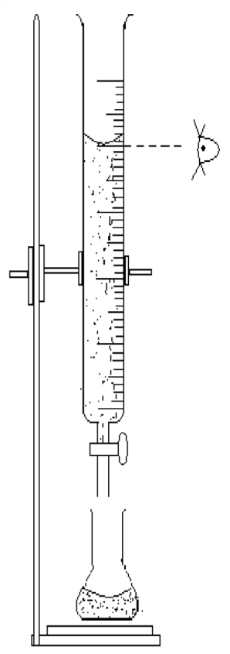

bring the meniscus of the acid to the 0 cm3 mark or slightly below it. Take the burette reading as

Eye at same

Burette

Dilute acid

Tap

V1 cm3.

1. Arrange the apparatus as shown on the left hand side. Run the acid solution from the burette drop wise. Use your left hand to open the tap and your right hand to swirl the conical flask (unless you are left handed). Stop when the indicator just changes color. This is the end point the titration.
2. Take the burette reading again V2 cm3. Subtract (V2- V1) cm3 to get the ―**titre**‖ (i.e. the volume of the acid needed to neutralize the known volume of alkali).
3. Repeat the titration. Obtain an average titre. From this volume you can calculate the unknown concentration.

Alkali solution

White tile

**N.B** The first titration is regarded as a trial run (rough titration) and may not be very accurate,

therefore the value may not be used in computing the average volume. Values used in calculating the average volume must be close to each other

## **Specimen readings**

***Example***

Neutralization of 0.1M NaOH solution with a solution of HCl Volume of pipette used =25.0cm3

Value used to calculate average volume of acid used: 15.00 cm3 and 15.00 cm3 Average volume of acid used==15.00 cm3

Calculate

1. The number of moles of sodium hydroxide that reacted
2. The number of moles of hydrochloric acid that reacted
3. The molarity of the hydrochloric acid ( i.e concentration in mol/litre)

**Method of calculation**

1. Write the equation for the reaction that took place. This gives you the mole ratio of reaction between the acid and the alkali.

HCl(aq) + NaOH(aq)NaCl(aq) + H2O(l) 1 mole of HCl neutralizes 1 mole of NaOH

1. Work out the number of moles of the standard solution. In this case it is the alkali (NaOH) as its concentration is known ( 25.O cm3 contains of 0.1M NaOH ).
   1. Moles of NaOH that reacted

1000cm3 of solution contains 0.1moles of NaOH

1 cm3 of solution contains ( ) moles of NaOH



25 cm3 of solution contains ( ) moles of NaOH

=0.0025 moles of NaOH

1. Work out the number of moles of the acid that reacted by relating the number of moles of the alkali to the mole ratio of reaction between the acid and alkali.
   1. From the equation of reaction

1 mole of NaOH reacts with 1 mole of HCl

0.0025 moles of NaOH reacts with () moles of HCl

=0.0025 moles of HCl

(since the mole ratio of the reaction of the HCl : NaOH is 1:1, so, the number of moles of HCl = 0.0025 moles)

1. Now work out the molarity of the acid
   1. 15cm3 of solution contains 0.0025moles of HCl 1cm3 of solution contains () moles of HCl



1000cm3 of solution contains () moles of HCl

=0.167 mol/*l* of HCl The molarity of the HCl is 0.167M

1. From the molarity, you can proceed and work out the concentration in grams/litre, if the Molar mass is known.(e.g. for 0.167M HCl in the above case)

Molar mass of HCl=(1+35.5)g = 36.5g 1 mole of HCl weighs 36.5g

0.167 moles of HCl weighs ()g

=6.1g/*l*

### ***Other examples***

1. 25cm3 of sulphuric acid of concentration 0.15mol/dm3 neutralized 31.2cm3 of potassium hydroxide solution. Find the concentration of the KOH solution in mol/l and in grams/litre.

*Solution*

***Write the equation***

Equation for the reaction

H2SO4 (aq) + 2KOH(aq) K2SO4(aq) + H2O(l)

1 mole of acid reacts with 2 moles of alkali

***Calculate the number of moles of the acid (standard solution) that reacted***

1000cm3 of solution contains 0.15moles of H2SO4

1 cm3 of solution contains ( ) moles of H2SO4



25 cm3 of solution contains ( )moles of H2SO4

=0.00375 moles of H2SO4

***Relate the number of moles of acid to the mole ratio of the reaction to find the number of moles of the alkali that reacted***

1 mole of H2SO4 reacts with 2 moles



of KOH

0.00375moles of H2SO4 reacts with ( ) moles of KOH

=0.0075 moles of KOH

***Calculate the molarity (concentration in mol/dm3) of the alkali***

31.2cm3 of solution contains 0.0075moles of KOH 1cm3 of solution contains () moles of KOH



1000cm3 of solution contains ( ) moles of KOH

=0.24 mol/*l* of KOH

The concentration of the KOH is 0.24 mol/*l* of KOH

***Proceed and calculate the concentration in g/l***

Molar mass of KOH= (39+16+1)= 56g 1 mole of KOH weighs 56g

0.24 moles of KOH weighs ()g

=13.44g

The concentration of the KOH is 13.44g/*l*

1. Determine the molarity of acids in the following solutions.
   1. 16.0cm3 of 1.5M sodium hydroxide neutralized by 20.0cm3 of hydrochloric acid
   2. 25.0cm3 of 0.2M ammonia solution neutralized by 20.0cm3 of nitric acid

*Solution*

1. Equation of reaction

HCl(aq) + NaOH(aq) NaCl(aq) +H2O(aq)

1000cm3 of solution contains 1.5moles of NaOH

1 cm3 of solution contains ( ) moles of NaOH



16 cm3 of solution contains ( ) moles of NaOH

=0.024 moles of NaOH

From the equation

1 mole of NaOH reacts with 1 mole of HCl,

0.024 moles of NaOH reacts with ( ) moles of HCl

=0.024 moles of

HCl

20.0cm3 of solution contains 0.024moles of HCl 1cm3 of solution contains () moles of HCl



1000cm3 of solution contains ( ) moles of HCl

=1.2 M HCl

The concentration of the HCl is 1.2M

Equation for reaction

1. HNO3(aq) + NH4OH(aq) NH4NO3(aq) +H2O(aq)

1000cm3 of solution contains 0.2moles of NH4OH

1 cm3 of solution contains () moles of NH 4OH 25cm3of solution contains () moles of NH4OH



=0.005 moles of NH4OH

From the equation

1 mole of NH4OH reacts with 1 mole of HNO3

0.005moles of NH4OH reacts with () moles of HNO3

=0.005 moles of HNO3 20.0cm3 of solution contains 0.005moles of HNO3 1cm3 of solution contains () moles of HNO 3



1000cm3 of solution contains ( )moles of HNO3

=0.25 M HNO3

The concentration of the HNO3 is 0.25M

1. 5.0g of a mixture of sodium chloride and anhydrous sodium carbonate were made up to 200cm3 of aqueous solution. 25cm3 of this solution required 40cm3 of 0.1M of hydrochloric acid for neutralization. What is the percentage by mass of the anhydrous sodium carbonate in the mixture?

*Solution*

Equation for the reaction

2HCl(aq) + Na2CO3(aq) NaCl(aq) +H2O(aq) + CO2(g)

1000cm3 of solution contains 0.1moles of HCl

1. cm3 of solution contains () moles of HCl 40cm3 of solution contains () moles of HCl



=0.004 moles of HCl

From the equation

1. mole of HCl reacts with 1 mole of Na2CO3

0.004 moles of HCl reacts with () moles of Na2CO3

=0.002 moles of Na2CO3

25.0cm3 of solution contains 0.002moles of Na2CO3 1cm3 of solution contains () moles of Na2CO3



1000cm3 of solution contains ( ) moles of Na2CO3

=0.08 M Na2CO3

The molarity of the Na2CO3 is 0.08M RMM of Na2CO3

=23x2+12+16x3

=106

1. mole of Na2CO3 weighs 106g

0.08 moles of Na2CO3 weighs () g

=8.48g of Na2CO3

The mass of Na2CO3 in 1 litre is 8.48g

200cm3 of solution contains 5.0g of mixture 1cm3 of solution contains ()g of mixture



1000cm3 of solution contains ( )g of mixture

=25g of the mixture.

The mass of a mixture of sodium carbonate and sodium chloride in 1 litre is 25g. Percentage mass of Na2COx 100



=34%

1. 3.5g of a mixture of K2CO3 and K2SO4 were made up to 250cm3 of aqueous solution. 25cm3 of the solution required 24.6cm3 of 0.1 HCl for complete neutralization.
   1. Write the equation for the reaction
   2. Determine the percentage by mass of potassium sulphate in the mixture.

*Solution*

1. 2HCl(aq) + K2CO3(aq) 2KCl(aq)

+ H2O(l) + CO2(g)

1. 1000cm3 of solution contains 0.1moles of HCl 1 cm3 of solution contains () moles of HCl

24.6cm3 of solution contains () moles of HCl

=0.00246 moles of HCl

From the equation

1. mole of HCl reacts with 1 mole of K2CO3

0.00246 moles of HCl reacts with () moles of K2CO3

=0.00123 moles of K2CO3

25.0cm3 of solution contains 0.00123moles of K2CO3 1cm3 of solution contains () moles of K2CO3



1000cm3 of solution contains ( ) moles of K2CO3

=0.0492 M K2CO3

The molarity of the K2CO3 is 0.0492M

RMM of K2CO3

=39x2+12+16x3

=138

1 mole of K2CO3 weighs 138g

0.0492 moles of K2CO3 weighs () g

=6.79g of K2CO3

The mass of K2CO3 in 1 litre is 6.79g

250cm3 of solution contains 3.5 g of mixture 1cm3 of solution contains ()g of mixture



1000cm3 of solution contains ( )g of mixture

=14g of the mixture.

The mass of a mixture of potassium carbonate and potasium sulphate in 1 litre is 14g.

Mass of K2SO4= mass of mixture-mass of K2CO3

=(14-6.79)g= 7.21g

Percentage by mass of K2SOx 100

=51.5%

**Calculating number of moles of water of crystallization**

The water of crystallization present in compounds does not take part in the reaction

1. Calculate the number of moles of water of crystallization in oxalic acid crystals, H2C2O4.xH2O from the following data.

5.0g 0f the crystals were made up to 250cm3 of aqueous solution and 25cm3 of this solution required 15.9 cm3 of 0.5M NaOH solution to neutralize it.

*Solution*

Equation for the reaction

2NaOH(aq) + H2C2O4(aq) Na2C2O4(aq) + 2H2O(l)

1000cm3 of solution contains 0.5moles of NaOH

1. cm3 of solution contains ( ) moles of NaOH



15.9 cm3 of solution contains ( ) moles of NaOH

=0.00795 moles of NaOH

From the equation

1. mole of NaOH reacts with 1 mole of H2C2O4,

0.00795 moles of NaOH reacts with () moles of H2C2O4

=0.003975 moles of

H2C2O4

25.0cm3 of solution contains 0.003975moles of H2C2O4 1cm3 of solution contains () moles of H2C2O4



1000cm3 of solution contains ( ) moles of H2C2O4

=0.159 M H2C2O4

The concentration of the H2C2O4is 0.159mol/dm3

250cm3 of solution dissolves 5 g of oxalic acid 1cm3 of solution contains ()g of oxalic acid



1000cm3 of solution contains ( )g of oxalic acid

=20g/*l* of the oxalic acid.

The mass of a oxalic acid in 1 litre is 20g. RMM of the oxalic acid

0.159 moles of H2C2O4.xH2O weighs 20g

1 mole of H2C2O4.xH2O weighs()g

=125.79g The RMM of H2C2O4.XH2O is 125.79≈ 126

There fore H2C2O4.xH2O = 126

1x2+12x2+16x4+ *x*(1x2+16) =126

90+18*x* =126

18x=126-90

18x=36 X=2.

The formula of the oxalic acid is H2C2O4.2H2O

1. 0.465g of a hydrated form of sodium carbonate exactly reacts with 75cm3 of 0.10M hydrochloric acid. Calculate the number of moles of water of crystallization present in one mole of the hydrated salt.

*Solution*

Equation for the reaction

2HCl(aq) + Na2CO3(aq) NaCl(aq) +H2O(aq) + CO2(g)

1000cm3 of solution contains 0.1moles of HCl

* 1. cm3 of solution contains () moles of HCl 75cm3 of solution contains () moles of HCl



=0.0075 moles of HCl

From the equation

* 1. mole of HCl reacts with



1 mole of

Na2CO3

0.0075 moles of HCl reacts with ( ) moles of Na2CO3

=0.00375 moles of Na2CO3

RMM of Na2CO3

=23x2+12+16x3

=106

1 mole of Na2CO3 weighs 106g

0.00375 moles of Na2CO3 weighs ( ) g



=0.3975g of

Na2CO3

Mass of water contained=(0.465-0.3975)g=0.0675g

The mole ratio of Na2CO3 : H2O is obtained by dividing each by the molar mass of the compound i.e. mole ratio of Na2CO

The formula is Na2CO3.H2O

**Calculating basicity of acids**

Basicity of an acid is the number of hydrogen ions that can be produced by one molecule of the acid upon complete ionization. It is not the number of hydrogen atoms in one molecule of an acid.

***Example***

1. Calculate the basicity of an acid HnZ if 15cm3 of 0.1M acid is completely neutralized by 9cm3 of 0.5 M potassium hydroxide.

Number of moles of the acid

1000cm3 of solution contains 0.1moles of HnZ

1 cm3 of solution contains () moles of H nZ 15cm3 of solution contains () moles of HnZ



=0.0015 moles of HnZ

Number of moles of KOH

1000cm3 of solution contains 0.5moles of KOH

1 cm3 of solution contains () moles of KOH 9cm 3 of solution contains () moles of KOH



=0.0045 moles of KOH

Equation of reaction

HnZ(aq) + nKOH(aq)K nZ(aq) + nH2O(l) Reaction ration,



0.0015n=0.0045

n= 3

### ***Exercise***

1. 11.2 g of potassium hydroxide were made up to 1 litre of aqueous solution. 25cm3 of this solution required 24.9cm3 of 0.1 M of an acid HnX. Dertermine the value of n in the acid(i.e the basicity of the acid) (**Answer=2**)
2. 1.5g of sodium hydroxide contained in 250cm3 of solution was used to titrate 0.1M hydrochloric acid. What volume of acid would be needed to react with 20cm3 of the alkali? (**Answer=30cm3**)
3. 8.50g of a sample of iron required just 75 cm3 of 3.00M hydrochloric acid to dissolve it and give a neutral solution. Calculate the percentage purity of the sample of iron.(**Answer=74.1%)**
4. Determine the number of moles of nitrate ions in 1 litre solution,if 6.62g of Lead(II)nitrate are made up to 200cm3 of aqueous solution.(**Answer=0.2 moles**)
5. Kyagulanyi and Atim were playing and accidentally poured an acid that was on the table in the drinking water for students. Samanya and Dickens, young analytical chemists titrate the water and find that 10.0dm3 of water are needed to neutralize 10.0cm3 of a 0.010moldm3 solution of sodium hydroxide. What is the concentration of the hydrogen ions in the water.(**Answer 0.00005M**)
6. Sodium carbonate crystals (27.823g) were dissolved in water and made up to 1 litre. 25.0 cm3 of the solution were neutralized by 48.8cm3 of hydrochloric acid of concentration 0.10M. Find n in the formula Na2CO3.nH2O.( **Answer n=10**)

***Sample questions on mole concept***

1. *25 cm3 of 0.1M* NaOH(aq) *required 12.5cm3 of Sulphuric acid solution for complete reaction. Calculate the.*
   1. *Molarity of the acid ii) Concentration of the acid in g/l.*
2. *25cm3 of a solution containing 5.3g/l of a metal carbonate of formula,* M2CO3

*neutralized 25cm3 of 0.1M Hydrochloric acid. Calculate the*

* 1. *Molarity of the carbonate solution ii)Formula mass of the metal carbonate iii)Relative atomic mass of the metal (M) in the metal carbonate.*

1. *25cm3 of impure sodium hydroxide solution containing 5.0g of impure sodium hydroxide per litre completely reacted with 20cm3 of 0.1M Hydrochloric acid. Calculate the;*
2. *molarity of Sodium Hydroxide solution*
3. *Percentage impurity in the sample of sodium Hydroxide.*
4. *1.00g of a mixture of calcium carbonate was carefully shaken with 200cm3 of distilled water, and then filtered. 20cm3 of the filtrate required 8cm3 of 0.125M*

*Hydrochloric acid for neutralization. Calculate*

* 1. *The mass of Calcium carbonate in the sample ii)*

*Percentage purity of sodium carbonate in the mixture*

1. *25cm3 of sodium carbonate required 27.25cm3 of a solution containing 4g of Hydrochloric acid per litre. Calculate the concentration of sodium carbonate in grams per litre of solution.*
2. *25cm3 of a solution containing 12.0g of sodium hydroxide per litre, required 15cm3 of a solution containing 18.25g/l of acid, HA. Calculate the formula mass of the acid.*
3. *20cm3 of 0.12M Potassium hydroxide required 24 cm3 of a solution of a dibasic acid,* H2X *containing 1.225g per 250cm3 of solution. Calculate the formula mass of the acid.*
4. *32.5cm3 of a solution containing 6.1 g/l of an acid,* HXO3*, required 25cm3 of a solution containing 5.0g/l of sodium hydroxide solution. Calculate the relative atomic mass of the acid.*
5. *20cm3 of a solution containing 25.8g/l of a dibasic hydrated acid,* H2X.nH2O *neutralized 10 cm3 of 0.8M sodium Hydroxide solution. If the relative formula mass of* H2X *= 90, determine the value of n*
6. *20cm3 of nitric acid solution containing 6.3g/l of solution required 25 cm3 of a metal carbonate,* M2CO3*, solution containing 5.52 g/l of solution for neutralization. Calculate the relative mass of metal* M*.*

**NITROGEN AND ITS COMPOUNDS**

Nitrogen is in period 2 and group (V) of the periodic table of elements. It has atomic number of 7 and electronic configuration 2:5.

**Occurrence**

Nitrogen exists freely in the air as diatomic molecules and makes up to 78% of the air by volume.

It occurs in combined states as nitrites, nitrates and most of these are distributed everywhere in soil as ammonium sulphate, sodium nitrate, potassium nitrate and calcium nitrate,. It is also constituent of living matter of pants and animals.

**Laboratory preparation of nitrogen a) From air**

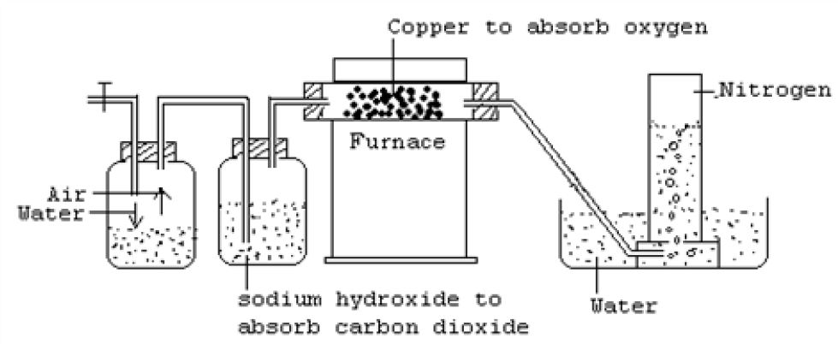**Set up**

Air is made to pass through a solution of concentrated sodium hydroxide to remove carbon dioxide gas

CO2 (g) + 2NaOH (aq) Na2CO3 (aq) + H2O (l)

The remaining air is then passed over heated copper to remove oxygen gas 2Cu(s) + O2 (g) 2CuO(s)

The nitrogen gas can now be collected over water.

If the nitrogen is required dry, it is then passed over fused calcium chloride to remove water vapour or it can be passed through a U tube containing beads soaked in concentrated sulphuric acid to dry the nitrogen gas.

NB. The nitrogen obtained by this method is denser than ordinary nitrogen since it contains impurities like argon and other inert gases.

1. **Preparation of nitrogen by action of heat on ammonium nitrite**

The ammonium nitrite is formed by the reaction between sodium nitrite and ammonium chloride.

NaNO2(aq) + NH4Cl(aq) NaCl(aq) + NH4NO2(aq)

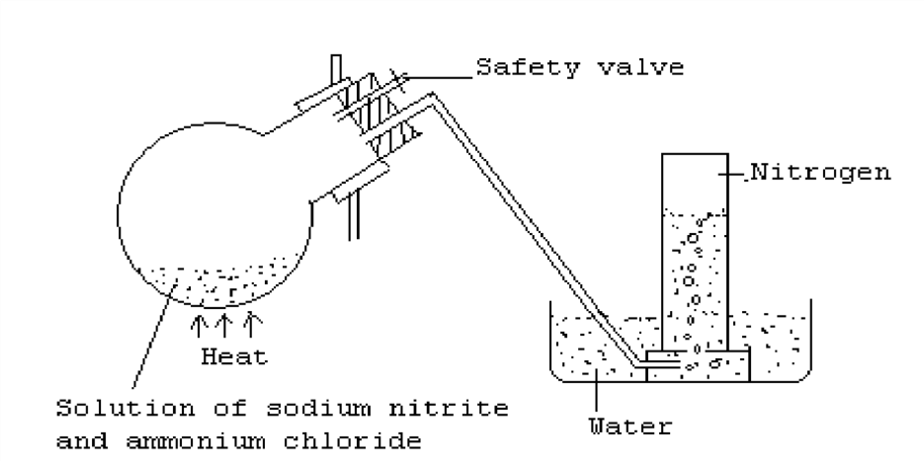On slight warming, the solution of ammonium nitrite decomposes to give nitrogen gas. The nitrogen gas produced can then be collected over water as shown.

NH4NO2(aq) N2(g) + 2H2O(l)

1. **Other methods**
   1. Action of chlorine on ammonia 3Cl2(g) + 8NH3(g)N 2(g) + 6NH4Cl(s)
   2. Passing ammonia over heated copper(II) oxide

3CuO(s) + 12NH3(g) 3Cu(s) + 3H2O(l) + N2(g) iii)

Reduction of oxides of nitrogen using copper 2NO2(g) + 4Cu(s)N 2(g) + 4CuO(s)

**Industrial preparation of nitrogen**

Nitrogen is obtained in the industry by fractional distillation of liquid air. Liquid air is fractionally distilled and nitrogen is obtained at a temperature of -196˚C (77 K at standard pressure). Oxygen with a higher boiling point (-183˚C ) is left behind. The separated nitrogen is liquefied and stored in specially designed container ready for use. The nitrogen may also be sold as compressed air.

**Properties of nitrogen Physical properties**

* It is a tasteless, colorless and odourless gas
* It is slightly soluble in water (almost insoluble)
* It is slightly denser than air
* It is a neutral gas i.e. neither acidic nor basic
* It does not support burning though a few metals burn in it.

**Chemical properties**

Nitrogen is generally an unreactive gas. This is because of the presence of the strong triple covalent bonds between its atoms in a molecule (N≡N). The triple covalent bonds are hard to break rendering nitrogen inert.

Some reactive metals like magnesium and calcium burn in nitrogen to form nitrides

i.e. magnesium nitride and calcium nitride

3Mg(s) + N2(g) Mg3N2(s)

(Green yellow)

3Ca(s) + N2(g) Ca3N2(s)

(Dark red)

The nitrides formed dissolves in water to form an alkaline solution of calcium and magnesium hydroxides; a gas with a choking smell (ammonia) is also given off.

Ca3N2(s) + 6H2O(l) 3Ca (OH)2(aq) + 2NH3(g)

Nitrogen reacts with hydrogen under special conditions to form ammonia (Haber process).

N2(g) + 3H2(g) 2NH3(g)

Nitrogen is inert and does not burn though is forms a number of oxides like nitrogen monoxide (NO), nitrogen dioxide (NO2) and dinitrogen oxide (N2O).

**Uses of nitrogen**

* Nitrogen is used in the synthesis of ammonia gas.
* It is used in the manufacture of fertilizers like ammonium phosphate.
* The atmospheric nitrogen is fixed by thunder or bacteria in root nodules of leguminous plants to nitrates which can be used by plants.
* Because of its low boiling points, liquid nitrogen is used to cool materials to very low temperatures.
* It is used in the manufacture of nitric acid.

**OXIDES OF NITROGEN**

**NITROGEN DIOXIDE (NO2)**

**Laboratory preparation**

It is conveniently prepared in the laboratory by heating lead(II) nitrate crystals (this is because lead(II) nitrate forms crystals without water of crystallization which is not common to other metallic nitrates and would otherwise interfere with the preparation)

Nitrogen dioxide is finally obtained as brown fumes 2Pb(NO3)2(s) 2PbO(s) + 4NO2(g) + 2O2(g)

NB.

1. The gas is passed through a freezing mixture of common salt and ice where it collects in a U tube as dinitrogen tetra oxide, N2O4(a pale green liquid which appears pale yellow when it is pure). The oxygen gas passes on and escapes as a colourless, harm less gas which can be collected if required over water as shown.
2. As the white lead(II) nitrate crystals are heated, they make a crackling sound and melt. This is known as decrepitation. The residue in the boiling tube is Lead(II) oxide which is yellow when it cools.

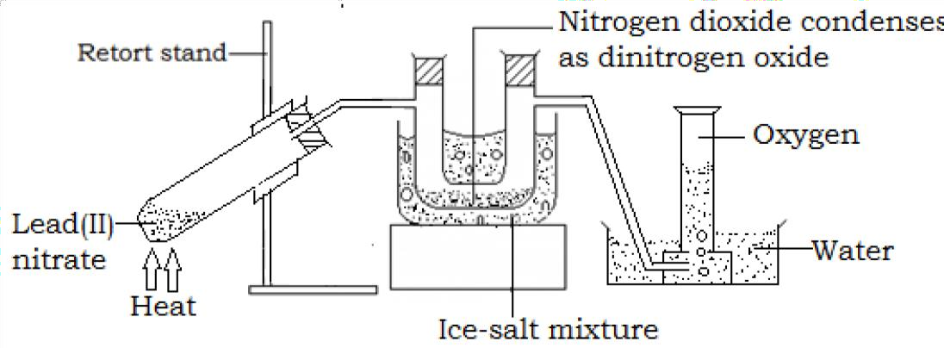

**Properties of nitrogen dioxide Physical properties**

* + It is reddish brown gas at room temperature
  + It is soluble in water
  + It is denser than air
  + It is highly poisonous and produces nitric acid in the lungs when inhaled (it causes septic pneumonia)
  + It has an irritating pungent smell
  + It is easily liquefied

**Chemical properties**

1. Burning of metals. Metals e.g. magnesium and non-metals like phosphorus burn even more highly in nitrogen dioxide. This suggests that nitrogen dioxide supports combustion and this will be so if the material reacting is hot enough to decompose nitrogen dioxide into oxygen (a gas that supports burning)

4Mg(g) + 2NO2(g) 4MgO(s) + N2(g)

2P4(s) + 10NO2(g) 2P4O10(s) + 5N2(g)

1. Nitrogen dioxide oxidizes red hot metals e.g. copper and zinc to their oxides and nitrogen dioxide is itself reduced to nitrogen.

4Cu(s) + 2NO2(g) 4CuO(s) + N2(g)

(Brown) (Black)

1. When the gas is heated above 150˚C, the brown colour of the gas tends to fade gradually giving a colourless gas which is a mixture of nitrogen monoxide and oxygen. This is called dissociation of nitrogen dioxide.

2NO2(g) 2NO(g) + O2(g)

(Brown) (Colourless)

N2O4 2NO2(g) 2NO(g) + O2(g)

(Green-impure)

(Pale yellow-pure) (Brown fumes) (Colourless)

1. Nitrogen dioxide dissolves in water to give a faint blue solution. This solution is a mixture of nitric acid and nitrous acid.

2NO2(g) + H2O(l) HNO3(aq) +HNO2(aq)

The nitrous acid formed is immediately oxidized by atmospheric oxygen to form nitric acid.

2HNO2(aq) + O2(g) 2HNO3(aq)

NB. Since nitrogen on dissolving in water produces two acids, it is said to be a **mixed acid anhydride**.

1. Nitrogen dioxide neutralizes alkalis to give the corresponding nitrate and a nitrite together with water.

2NO2(g) + 2NaOH(aq) NaNO3(aq) + NaNO2(aq) + H2O(l)

**Uses of nitrogen dioxide**

* + It is used in the manufacture of plastics, explosives, nylon materials e.t.c.
  + Used in the manufacture of nitric acid.

**NITROGEN MONOXIDE (NO)**

**Laboratory preparation Set up**

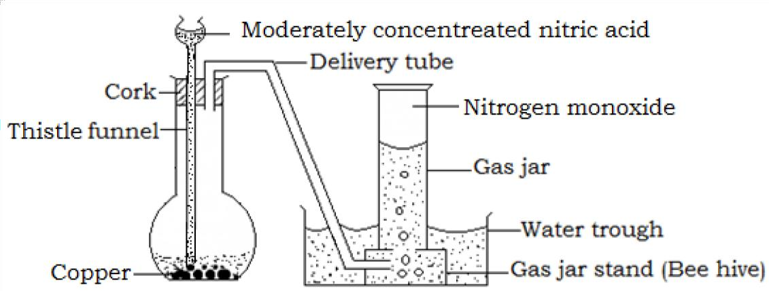

**Procedure**

Place some copper turnings in a flask, add some water to cover it, then add moderately concentrated (50%) nitric acid (same volume as that of the water).

**Observation**

Vigorous effervescence occurs and the flask is filled with brown fumes. The brown fumes are nitrogen dioxide produced partly by the action of the acid upon the copper and partly by the oxidation of the main product, nitrogen monoxide by the oxygen of the air in the flask.

2NO(g) + O2(g) 2NO2(s)

The brown fumes dissolve in water over which the nitrogen monoxide is collected as a colourless gas. A green solution of copper (II) nitrate is left in the flask.

3Cu(s) + 8HNO3(aq) 3Cu(NO3)2(aq) + 4H2O(l) + 2NO(g)

**Properties of nitrogen monoxide**

1. It does not normally support combustion and a burning splint is extinguished when placed in a gas jar of nitrogen monoxide. However, it supports combustion of very hot substances like magnesium and phosphorus which provide temperatures hot enough to decompose the gas into oxygen. E.g

2Mg(s) + 2NO(g) 2MgO(s) + N2(g)

2P4(s) + 10NO(g) 2P4O5(s) + 5N2(g)

1. It is a neutral gas and has no effect on litmus paper.
2. **Chemical test**

When the gas is exposed to air, nitrogen monoxide immediately reacts with atmospheric oxygen to form brown fumes of nitrogen dioxide.

2NO(g) + O2(g) 2NO2(s)

**Alternative test**

When the gas is bubble though iron(II) sulphate solution, the solution changes from pale green to dark brown or black. The dark brown of black coloration is due to formation of a compound, (FeSO4).NO. When this compound is heated, pure nitrogen monoxide is formed.

**DINITROGEN OXIDE, N2O (LAUGHING GAS)**

**Laboratory preparation Set up**

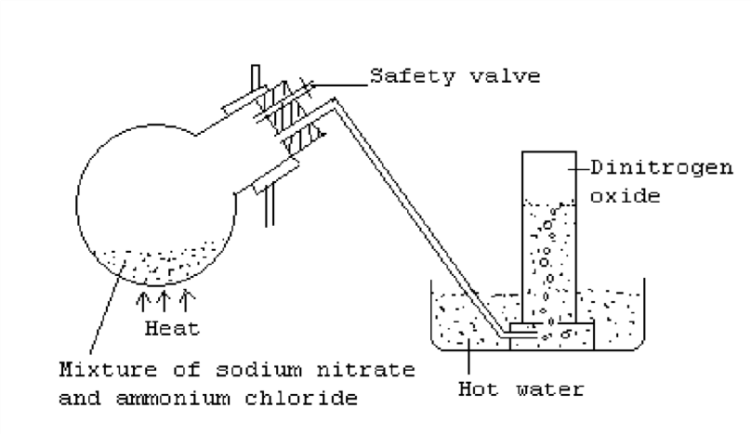

**Procedure**

1. Grind a mixture of sodium nitrate and ammonium chloride.
2. Put the mixture in a round bottom flask and assemble the apparatus as shown in the diagram above.

NB. On heating the mixture, ammonium nitrate is formed which quickly decomposes to give dinitrogen oxide and water vapour.

NaNO3(s) + NH4Cl(s)NH 4NO3(s) + NaCl(s) NH4NO3(s) N2O(g) + 2H2O(g)

The dinitrogen oxide is then collected over hot water.

NB. It could also be prepared by heating ammonium nitrate directly but this method is dangerous since ammonium nitrate can be explosive when heated.

**Physical properties of dinitrogen oxide**

* 1. It is a colourless gas with a faint sweet smell.
  2. In it fairly soluble in cold water but insoluble in hot water.
  3. It is denser than air. iv) It can be easily liquefied.

1. It is a neutral gas and has no effect on litmus paper.

**Chemical properties of dinitrogen oxide**

* 1. It supports combustion and relights a glowing splint that is hot enough to decompose it into oxygen and nitrogen.
  2. Burning metals and non metals like magnesium and sulphur continue to burn in the gas giving their respective oxides.

N2O(g) + Mg(s) MgO(s) + N2(g)

2N2O(g) + S(s) SO2(g) + 2N2(g)

Other metals like copper when they are very hot can be oxidized by the gas to their respective oxides.

N2O(g) + Cu(s) CuO(s) + N2(g)

**Use of dinitrogen oxide**

It is used as an anaesthetic in less complex surgical operations like dentistry. It has an effect that makes a patient laugh hysterically and it is therefore referred to as

―laughing gas‖.

**AMMONIA**

**Laboratory preparation Setup**

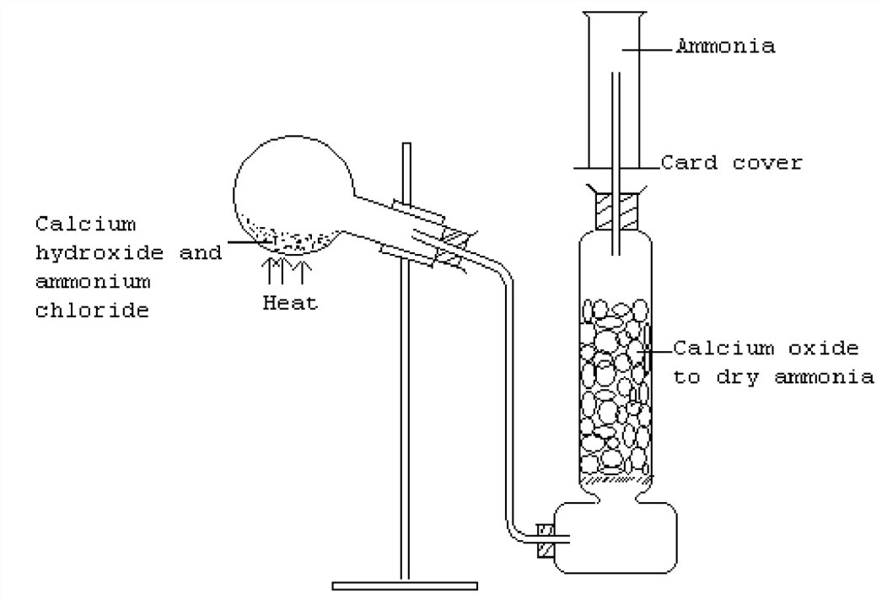

**Procedure**

* Assemble the apparatus as shown in the diagram above
* Grind a mixture of ammonium chloride and calcium hydroxide and place it in a round bottom flask of a hard glass

NB. The neck of the flask should bend down wards and the flask should be in a slanting position because the formed water vapour will condense and if allowed to run back on the hot flask causes breakage

* Heat the mixture in the flask to evolve ammonia gas **Equation**

Ca(OH)2(s) + 2NH4Cl(s) 2NH3(g) + CaCl2(s) + 2H2O(l)

* The gas is then dried by passing it over lumps of calcium oxide. The usual drying agents i.e. fused calcium chloride and concentrated calcium chloride react with the gas as below.

2NH3(g) + H2SO4(l) (NH4)2SO4(s)

CaCl2(s) + 4NH3(g) CaCl2.4NH3(s)

Since the gas is less dense than air and very soluble in water, it is collected by upward delivery method.

Ammonia gas can be prepared in the laboratory by heating any ammonium salt with an alkali.

**Properties of ammonia Physical properties**

* + 1. Ammonia is a colourless gas with a characteristic choking smell.
    2. It is less dense than air. iii) It has a very low boiling point (-34˚C) and liquefied under pressure. iv) It is very soluble in water. It is in fact the most soluble gas known.

v) It turns moist red litmus paper blue. It is the only known alkaline gas.

**Solubility of ammonia in water The fountain experiment**

The great solubility of ammonia is illustrated by the fountain experiment.

**Set up**

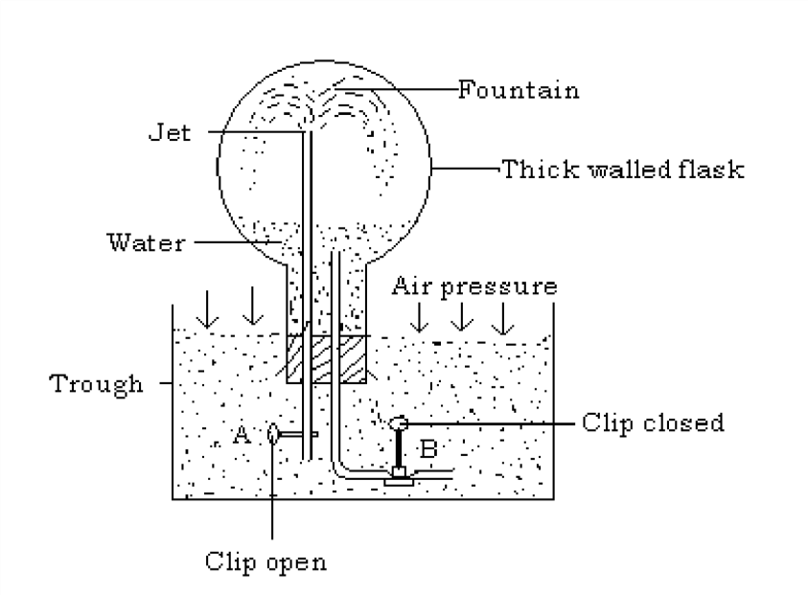

**Procedure**

* Fill a dry thick walled flask with ammonia gas and close it with a cork carrying tubes and clips as shown.
* Clamp the flask upside down and immerse the tubes with clips inside water which has been coloured with red litmus solution.
* Open clip B for a moment and close it. This allows few drops of water to enter in the flask. The water is made to run to the round end of the flask.

The ammonia gas in the flask dissolves in the water (forming a blue solution since it is an alkaline gas). This greatly reduces the gas pressure inside the flask.

* Open clip A.

**Observation**

A fountain at once occurs as illustrated in the diagram. This will continue until the flask is full of water as it was with ammonia. When clip A was opened, water was forced into the flask because the atmospheric pressure from the outside was far much greater than the pressure inside the flask. The fountain appears blue due to the alkaline nature of ammonia gas.

**Chemical properties of ammonia Reaction with air**

When a lit splint is placed in a gas jar full of ammonia, it is extinguished showing that ammonia does not support combustion. On its own, ammonia does not burn but in plenty of oxygen, ammonia burns to produce nitrogen and water vapour.

4NH3(g) + 3O2(g) 2N2(g) + 6H20(g)

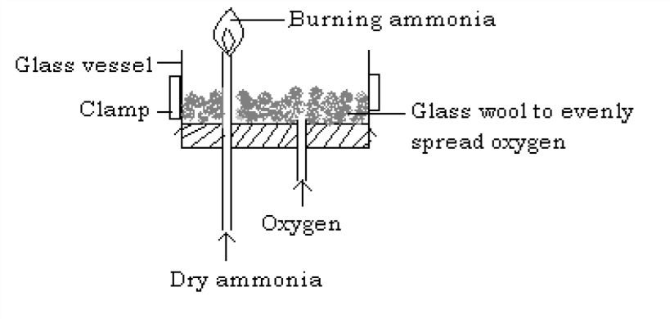

In the presence of a catalyst e.g. platinum foil, ammonia it oxidized to nitrogen monoxide when it reacts with oxygen/air. In this case, the platinum foil continues to glow in the mixture of air and ammonia since the reaction is exothermic. Brown fumes of nitrogen dioxide are later seen as the nitrogen monoxide formed is oxidized in the

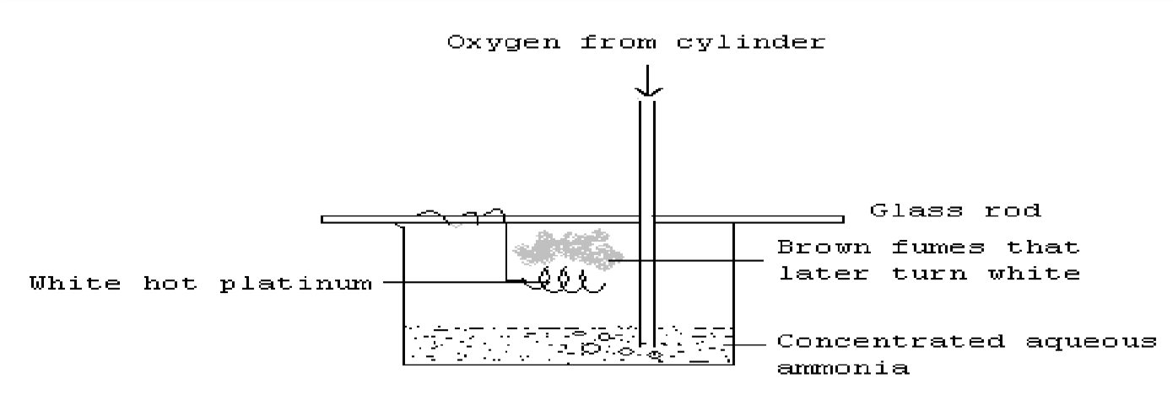presence of oxygen.

4 NH 3 (g) + 5O 2 (g) 4NO(g) + 6H 2 O(g)

2 NO(g) + O 2 (g) 2NO 2 (g )

This reaction is known as **Ostwald’s catalytic oxidation of ammonia**. It is the initial stage in the commercial preparation of nitric acid.

The fumes then later turn white due to the formation of ammonium nitrate according to the following reactions.

2H2O(g) + 4NO2(g) + O2(g) 4HNO3(g) HNO3(g) + NH3(g) NH4NO3(g)

**Reaction with hydrogen chloride gas**

Ammonia reacts with hydrogen chloride to form dense white fumes of ammonium chloride which settle as white solids.

NH 3 (g) + HCl(g)

NH

4 Cl(s)

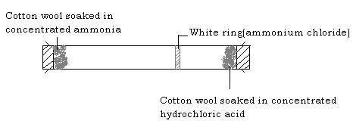

#### Reaction with chlorine

When ammonia reacts with chlorine, ammonia reduces chlorine to hydrogen chloride and its self is oxidized to nitrogen.

2NH3(g) + 3Cl2(g) 6HCl(g) + N2(g)

When ammonia is in excess, dense white fumes of ammonium chloride are formed.

HCl(g) + NH3(g) NH4Cl(s)

**Reaction with metal oxides**

Ammonia reduces oxides of metals below iron in the reactivity series to respective metals and itself is oxidized to nitrogen and water. E.g when ammonia is passed over heated copper(II) oxide, the oxide changes from black to brown as copper metal is formed.

3 CuO(s) + 2NH 3 (g) 3Cu(s) + N 2 (g) + 3H 2 O(l)

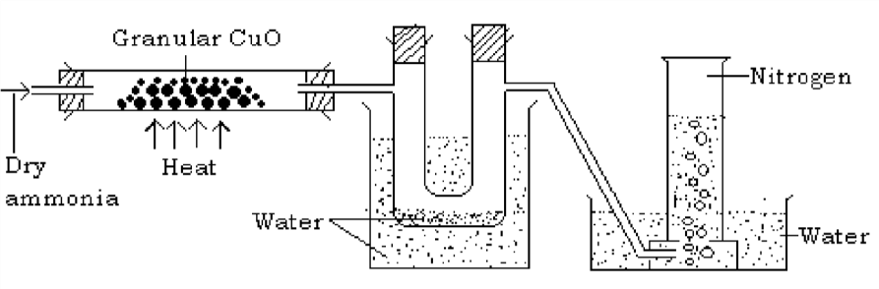

The colourless liquid collected in the U tube turns white anhydrous copper(II) sulphate blue indicating that it is water.

**Reaction with water**

Ammonia gas dissolves in water to form an alkaline solution of ammonium hydroxide.

NH3(g) + H2O(l) NH4OH(aq)

NH3(g) + (aq) NH3(aq)

Setup for the preparation of ammonium solution

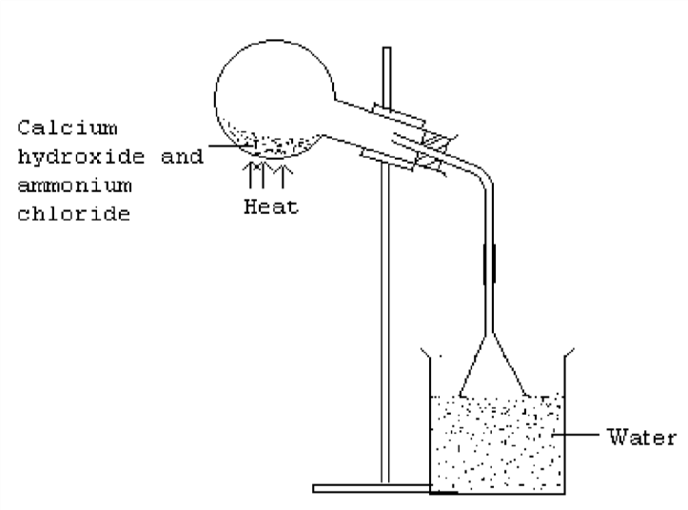

A mixture of ammonium chloride and calcium hydroxide is heated to produce ammonia gas which then dissolves in water to form the alkaline solution of ammonium hydroxide.

**Precaution:** The rim of the inverted funnel should just touch the surface of water. This prevents the water from being sucked into the flask.

**Reaction with acids**

Ammonia solution (aqueous ammonia) has many properties of typical alkaline solutions. E.g. it reacts with acids to form ammonium salts.

NH4OH(aq) + HCl(aq) NH4Cl(aq) + H2O(l) (NH3(aq) + HCl(aq) NH4Cl(aq)) NH4OH(aq)+H2SO4(aq) (NH4)2SO4(aq)+H2O(l) (NH3(aq)+H2SO4(aq) (NH4)2SO4(aq))

These salts can be crystallized out and are similar to ordinary metallic salts.

**Reaction of aqueous ammonia with metallic ions**

When aqueous ammonia is added to a solution of metallic salt, it forms precipitate of the insoluble metal hydroxide.

For example when a solution containing copper (II) ions e.g. copper (II) sulphate solution is put in a test tube and aqueous solution of ammonia added to it a little, pale blue precipitates of copper (II) hydroxide are formed.

CuSO4(aq) + 2NH4OH(aq) (NH4)2SO4(aq) + Cu(OH)2(s)

(pale blue precipitate)

Ionic equation

(aq) + 2 (aq) Cu(OH)2(s)

When the ammonia solution is added until in excess, the pale blue precipitates dissolve giving a deep blue solution. The deep blue solution is due to the formation of a complex salt containing tetra amine copper (II) ion.

Cu(OH)2(s) + 4NH3(aq) Cu(NH3)42+(aq) + 2 (aq)

Examples of metallic ions that react with ammonium solution are;

(aq) + 2 (aq) Fe(OH)2(s)

(Green precipitate)

(aq) + 3 (aq) Fe(OH)3(s)

(Brown precipitate)

(aq) + 2 (aq) Pb(OH)2(s)

(White precipitate)

(aq) + (aq) Zn(OH)2(s)

(White precipitate)

(aq) + (aq) Al(OH)3(s)

(White precipitate)

However, sodium hydroxide and ammonium hydroxide are different in that:

1. The pale blue precipitates of copper(II) hydroxide do not dissolve in excess sodium hydroxide but dissolves in excess ammonia solution forming a deep blue solution.
2. The amphoteric aluminium and lead ions dissolve in excess sodium hydroxide but not in excess ammonia solution.
3. Zinc dissolves in both excess sodium hydroxide and ammonia solution but the reactions are different.

Zn(OH)2(s) + 2 (aq) Zn(OH)42-(aq)

(zincate ion)

Zn(OH)2(s) + 4NH3(aq) Zn(NH3)42+(aq) + 2 (aq)

(tetrammine zinc ion )

**Manufacture of ammonia (Haber process)**

Large scale manufacture of ammonia is done through the Haber process by the synthesis of ammonia from its elements, hydrogen and nitrogen.

N2(g) + 3H2(g)  ~~2~~NH3(g) + heat

The raw materials for the process are hydrogen and nitrogen.

**Process**

Dry nitrogen and hydrogen in the ration of 1:3 by volume are mixed in the presence of a finely divided iron catalyst and the mixture heated.

**Condition**

The heating is carried out at a very high pressure of about 200-400 atmospheres and at a temperature of 400-500˚C in the presence of a catalyst (finely divided iron impregnated with alumina). The reaction is exothermic and reversible.

Note

1. The two gases (hydrogen and nitrogen) must first be purified. This is because the impurities may poison the catalyst. The impurities that must be removed include: water vapour; dust; carbon dioxide and sulphur dioxide.
2. The raw materials for the process are obtained from various sources e.g. the nitrogen is obtained from fractional distillation of liquid air, hydrogen from steam reforming of natural gas.

The ammonia gas produced is then liquefied and stored for future use.

**Discussion conditions for the Haber process Effect of pressure**

The formation of ammonia proceeds with a decrease in volume i.e. 4 volumes of reactants give 2 volumes of products.

N2(s) + 3H2(g) 2NH3(g)

4 volumes 2 volumes

High pressure would increase the yield of ammonia since the reaction proceeds with a decrease in volume. There fore a pressure of 200-500 atm is used. At a high pressure, the reacting molecules collide more frequently thus increasing the rate of the reaction.

**Effect of temperature**

The formation of ammonia from its elements is an exothermic reaction and there fore low temperature will cause a better yield of ammonia. But at low temperature, the reaction will be slow thus a moderate temperature of 400-500˚C is used together with a catalyst.

**Effect of a catalyst**

To make the reaction proceed faster, a catalyst is used. The catalyst used is finely divided iron impregnated with alumina. The catalyst should be finely divided to increase on the surface area since the reaction occurs at the surface.

**Effect of concentration**

Since the reaction is reversible, we use in excess any of the reactants inorder to get a better yield of ammonia. However, in practice, nitrogen and oxygen are used in the ratio of 1:3 respectively.

**Uses of ammonia**

* It is used in the manufacture of fertilizers like ammonium phosphate and urea.
* Ammonia solution is used to soften hard water.
* Ammonia is used in the manufacture nitric acid.
* Liquid ammonia is used in large scale refrigerating plants such as in ships and ware houses.
* It is used in the manufacture of sodium carbonate in the Solvay process.

**Ammonium salts**

* 1. All common ammonium salts are white crystalline substances; soluble in water and are ionic compounds.
  2. The sulphates, nitrates and chlorides dissolve in water to form an acidic solution.

NH4Cl(s) + H2O(l) NH4OH(aq) + HCl(aq)

The ammonium chloride dissolves to form a weak ammonium hydroxide solution and strong hydrochloric acid. The ammonium hydroxide is too weak to neutralize the effect of the strong hydrochloric acid and thus the resultant solution is acidic in nature.

* 1. All ammonium salts sublime except ammonium sulphate.

NH4Cl(s) NH3(g) + HCl(g)

NH4NO3(s) N2O(g) + 2H2O(g) (NH4)2CO3(s) CO2(g) + H2O(g) + 2NH3(g)

It is only ammonium sulphate that does not sublime

(NH4)2SO4(s) H2SO4(g) + 2NH3(g)

* 1. All ammonium salts liberate ammonia gas upon heating with an alkali

e.g. sodium hydroxide solution. aq) + (aq) NH3(g) + H2O(l)

This reaction serves as a confirmatory test for the presence of ammonium ion.

**NITRIC ACID**

**Laboratory preparation**

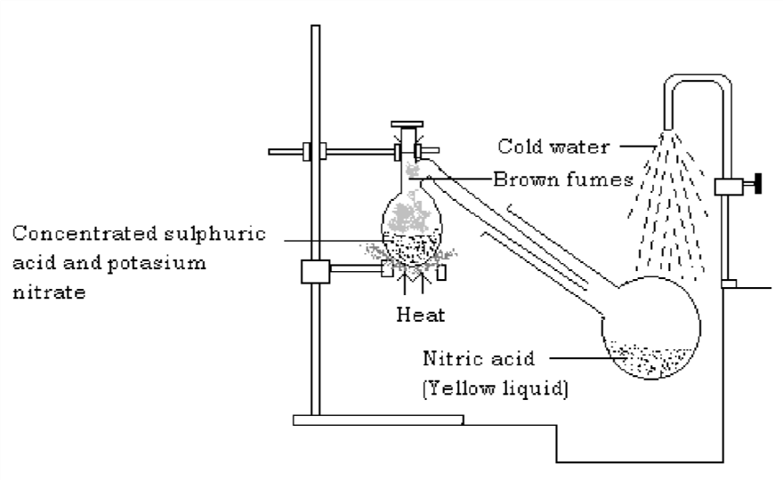Set up

**Procedure**

* Assemble the glass apparatus as shown in the diagram above.
* Put some potassium nitrate crystals or sodium nitrate crystals in the bulb of the retort with concentrated sulphuric acid.
* Heat the mixture gently and then collect the nitric acid in a water cooled receiver.

**Observation**

The potassium nitrate crystal gradually dissolves and effervescence occurs. KNO3(s) + H2SO4(aq)KHSO 4(s) + HNO3(g)

The nitric acid distills and collects in the cooled receiver as a yellow liquid (the yellow colour is due to the presence of dissolved nitrogen dioxide gas), while drops of the acid can be seen running down the bulb and neck of the retort. The brown fumes are nitrogen dioxide formed by slight decomposition of the nitric acid by heat.

4HNO3(l) 2H2O(l) + 4NO2(g) + O2(g)

NB. The apparatus used must be glass because nitric acid quickly attacks other materials like cork and rubber tubing.

Any metallic nitrate when heated with concentrated sulphuric acid produces nitric acid.

NaNO3(s) + H2SO4(l) NaHSO4(aq) + HNO3(aq)

**Industrial Preparation of nitric acid (The Ostwald’s process)**

Nitric acid is manufactured by the catalytic oxidation of ammonia and then dissolving the products in water.

**Major steps**

1. Ammonia from the Haber process is mixed with excess air and passed over a platinum (90%)/rhodium (10%) gauze catalyst. The catalyst is heated to red hot to start the reaction and since the reaction is exothermic, no heating is required once the reaction starts. Here ammonia is oxidized to colorless dinitrogen gas.

4NH3(g) + 5O2(g) 4NO(g) + 6H2O(l)

1. The nitrogen monoxide formed is rapidly cooled and combines with the oxygen from the excess air to form nitrogen dioxide.

2NO(g) + O2(g) 2NO2(g)

1. The nitrogen dioxide, in the presence of more air is absorbed in hot water to form the nitric acid.

2H2O(l) + 4NO2(g) + O2(g) 4HNO3(aq)

**Properties of nitric acid Physical properties**

i) It is a colourless fuming liquid (if pure) ii) It is corrosive just like other acids

1. It turns blue litmus red and has no effect on red litmus paper

**Chemical properties**

* 1. **Thermal decomposition**

Upon heating, concentrated nitric acid decomposes to give off brown fumes of nitrogen dioxide, oxygen and water vapour.

4HNO3(aq) 4NO2(g) + O2(g) + 2H2O(l)

* 1. **Acid reactions of nitric acid**
     1. Dilute nitric acid is neutralized by alkalis to form a salt and water only.

NaOH(q)+ HNO3(aq) NaNO3(aq) + H2O(l)

* + 1. Carbonates are decomposed by dilute nitric acid to form the corresponding nitrate, water and carbon dioxide.

Na2CO3(aq) + 2HNO3(aq) 2NaNO3(aq) + CO2(g) + H2O(l)

* + 1. Hydrogen gas is liberated when very dilute nitric acid is made to react with highly electropositive metals like magnesium and zinc.

Mg(s) + 2HNO3(aq) Mg(NO3)2(aq) + H2(g)

Other metals do not react with dilute nitric acid to produce hydrogen, they are simply oxidized to their corresponding nitrates and the nitric acid is reduced to nitrogen dioxide.

* 1. **Oxidation reactions of nitric acid**

Concentrated nitric acid is a powerful oxidizing agent i.e. it readily gives up its oxygen. It converts most metals to their corresponding nitrates and non-metals such as carbon are oxidized to their oxides. In all cases, nitric acid is itself reduced to nitrogen dioxide. For example

* + 1. Concentrated nitric acid oxidizes brown copper metal to copper (II) nitrate and the nitric acid is itself reduced to nitrogen dioxide.

Cu(s) + 4HNO3(aq) Cu(NO3)2(aq) + 2NO2(g) + 2H2O(l)

However, when moderately concentrated nitric acid (50%) is used, nitrogen monoxide is instead formed.

3Cu(s) + 8HNO3(aq) 3Cu(NO3)2(aq) + 2NO(g) + 4H2O(l)

No heating is required for this reaction.

Concentrated nitric acid renders iron and aluminium passive due to formation of an oxide layer which serves as a protective coating and therefore prevents the metals from reacting any further.

* + 1. Hot concentrated nitric acid oxidizes carbon to carbon dioxide and itself reduced to nitrogen dioxide.

C(s) + 4HNO3(l) CO2(g) + 4NO2(g)+ 2H2O(l)

* + 1. Hot concentrated nitric acid oxidizes red hot phosphorus to phosphoric acid.

P(s) + 5HNO3(aq) H3PO4(aq) +5NO2(g) + H2O(l)

* + 1. Concentrated nitric acid oxidizes sulphur to sulphuric acid it self reduced to nitrogen dioxide.

S(s) + 6HNO3(aq) H2SO4(aq) + 6NO2(g) + 2H2O(l)

* + 1. When hydrogen sulphide is bubbled through a concentrated solution of nitric acid, a yellow deposit of sulphur is formed and nitric acid is reduced to brown fumes of nitrogen dioxide.

H2S(g) + 2HNO3(aq) S(s) + 2NO2(g) + H2O(l)

* + 1. Concentrated nitric acid oxidizes acidified green iron(II) sulphate to brown/yellow iron(III) sulphate and itself reduced to nitrogen monoxide (colourless) which is then oxidized immediately in air to form nitrogen dioxide (brown fumes).

FeSO4(aq) + 3H2SO4(aq) + 2HNO3(aq)Fe 2(SO4)3(aq) + 2NO(g) + 4H2O(l) 2NO(g) + O2(g) 2NO2(g)

**Uses of nitric acid**

* It is used in the manufacture of dyes.
* It is used in the manufacture of fertilizers e.g. ammonium nitrate.
* Used in the manufacture of explosives.
* Since it is an oxidizing agent, it is used in the manufacture of nylon.
* It is used in the refining of precious metals.

**NITRATES**

These are salts of nitric acid. All nitrates are soluble in water.

**Action of heat on nitrates**

All the nitrates decompose on heating. The thermal decomposition of metal nitrates depends upon the position of the metal in the reactivity series.

When potassium and sodium nitrates are heated, they melt into colourless liquid decompose to give pale yellow nitrites and oxygen gas. E.g.

2NaNO3(s) 2NaNO2(l) + O2(g)

(Pale yellow)

From calcium to copper, the nitrates are decomposed on heating to form oxides of the metal, brown fumes of nitrogen dioxide gas and oxygen gas (relights a glowing splint). E.g. when white crystals of lead(II) nitrate is heated, it produces a cracking sound, brown fumes of nitrogen dioxide and a colourless gas that relights a glowing splint (oxygen gas). A residue of lead(II) oxide (brown when hot; yellow when cold) is left.

Pb(NO3)2(s) PbO(s) + NO2(g) + O2(g)

(White crystals) (Brown-hot: yellow-cold)

Mg(NO3)2(s) MgO(s) + NO2(g) + O2(g)

(White) (white solids)

Zn(NO3)2(s) ZnO(s) + NO2(g) + O2(g)

(White) (Yellow-hot: white-cold)

Cu(NO3)2(s) PbO(s) + NO2(g) + O2(g)

(Blue) (Black)

From silver to gold, their nitrates decompose to give corresponding metals, nitrogen dioxide (brown fumes) and oxygen gas (colourless gas that relights a glowing splint).

2AgNO3(s) 2Ag(s) + 2NO2(g) + O2(g)

Hg(NO3)2(s) Hg(s) + 2NO2(g) + O2(g)

Ammonium nitrate decomposes explosively when heated into dinitrogen oxide and water.

NH4NO3(s) N2O(g) + 2H2O(l)

**Test for nitrates**

All nitrates irrespective of their position in the reactivity series undergo the same reaction with iron(II) sulphate and concentrated sulphuric acid and the reaction is used as a test for all soluble nitrates.

**Procedure**

To the nitrate solution in a test tube, add an equal volume of freshly prepared iron(II) sulphate solution. The test tube is tilted and concentrated sulphuric acid is carefully poured down the side of the test tube.

**Observation**

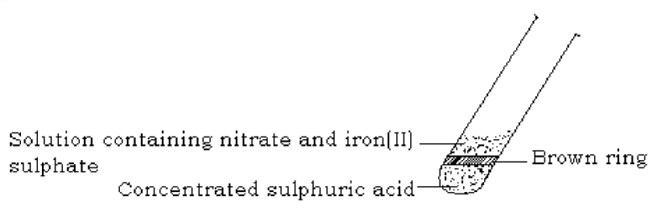A brown ring is formed at a junction between sulphuric acid and iron(II) sulphate. The brown ring is of a compound with the formula FeSO4.NO.

The brown ring is formed when concentrated sulphuric acid reacts with nitrate ions to give nitric acid.

H2SO4(aq) + (aq) 2HNO3(aq) + (aq)

The nitric acid formed oxidizes iron(II) to iron(III) and itself is reduced to nitrogen monoxide.

Fe2+(aq) Fe3+(aq)

+ e-

4HNO3(aq) 4NO(g) + 2H2O(l) + 3O2(g)

The nitrogen monoxide then combines with some of the iron(II) sulphate to form the complex FeSO4.NO (brown ring).

FeSO4(aq) + NO(g) FeSO4.NO(aq)

**The nitrogen cycle**

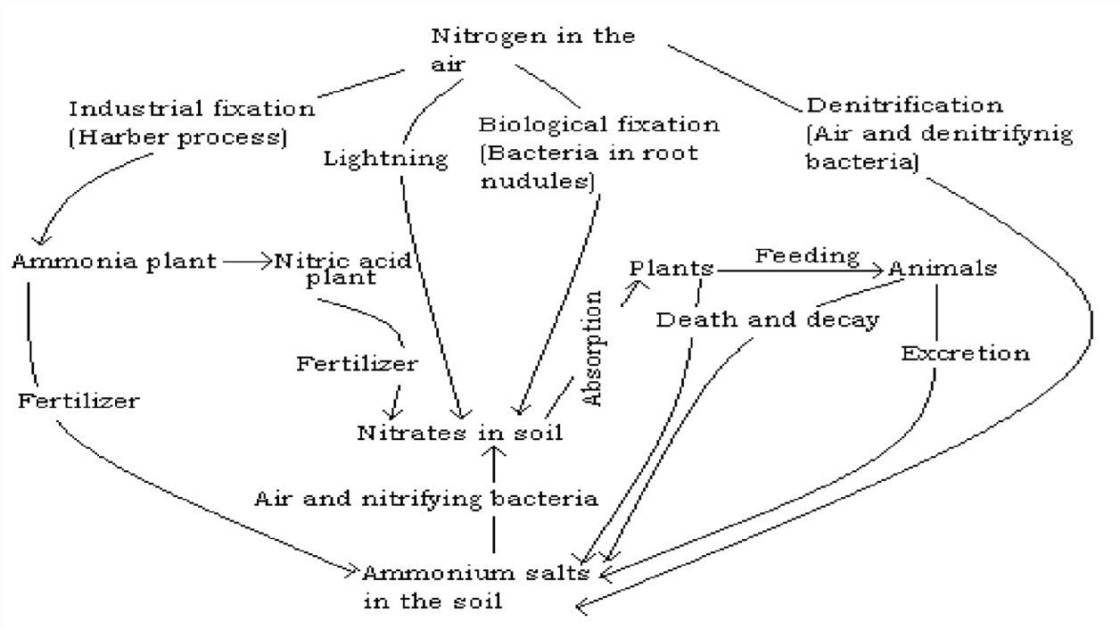This is a balance that exists between reactions that take nitrogen out of the air and out of the soil and reactions that put nitrogen into the air and into the soil. Nitrogen constitutes 78% by volume of air and it is an essential element in all living things.

Plants obtain nitrogen mainly in form of dissolved nitrates by absorption from the soil. When the nitrogen in the soil is not replenished, it leads to infertility and poor yield in crops. Animals obtain nitrogen by feeding on plants. Nitrogen is supplied to the soil through: death and decay of plants and animals; excretion by animals; nitrogen fixation by colonies of bacteria in root nodules and bacteria that live freely in the soil; lightning -causes some slight combination of nitrogen and oxygen which leads to passage of nitrogen into the soil as nitrates; industrial fixation through Haber process forming nitrogenous fertilizers such as ammonium sulphate. Denitrifying bacteria such as *Pseudomonas denitrificans* convert ammonium salts in the soil to atmospheric nitrogen

*Sample question on Nitrogen and its compounds*

1. *Outline briefly how a sample of nitrogen can be obtained from (a) air, (b) an ammonium salt.*

*Describe an outline of the industrial process showing how nitrogen is converted to ammonia. The reaction involved in this process is reversible. Indicate three*

*ways in which the yield of ammonia can be made maximum. State two industrial uses of ammonia.*

1. *Make a fully labeled drawing and give equation to show how you would prepare dry sample of ammonia in the laboratory starting from a named ammonium salt and a named alkali.*

*Giving equations and reaction conditions, outline how nitric acid is manufactured from ammonia.*

1. *Describe the action of heat on ammonium chloride. By what reaction would you obtain (i) ammonia from ammonium chloride (ii) nitrogen from ammonia? How can you account for the fact that a solution of ammnia in water will turn litmus blue and give brown precipitate when mixed with a olution of iron(II) chloride?*
2. *Describe how ammonia is manufactured from its elements. State the source of each element. Outline three differences between nitrogen/hydrogen mixture and ammonia. How would you show that ammonia is a very soluble gas?*
3. *Explain how ammonia is converted into nitric acid on a large scale. Describe two reactions in which nitric acid (i) acts as an acid (ii) acts as an oxidizing agent. Outline some uses of nitric acid. Calculate the percentage of nitrogen in pure ammonium nitrate.*

*Describe with equations what happens when ammonia is passed (i) into dilute sulphuric acid, (ii) over heated copper(II) oxide.*

1. *Nitric acid can be prepared in the laboratory by heating solid sodium nitrate with concentrated sulphuric acid. Make a labeled drawing of the apparatus you would*

*use for the preparation and write equation for the reaction. Explain why sulphuric acid is used in this preparation rather than hydrochloric acid.*

1. *Describe an experiment to show how nitrogen dioxide is prepared in the laboratory.*

*Describe the oxidation reaction of nitrogen dioxide, use equations to illustrate. Mention two uses of nitrogen dioxide.*

1. *With the aid of equations, describe the reactions of ammonia with: oxygen, hydrogen chloride, chlorine, water, metal oxides and metallic ions.*

**CHLORINE AND ITS COMPOUND**

The four nonmetals fluorine, chlorine, bromine and iodine make up a family of related elements called **halogens** meaning salt producers since they react with most metals to form electrovalent salt like compounds.

**Preparation of chlorine**

Chlorine can be generally prepared by the removal of hydrogen from hydrochloric acid i.e. oxidation of hydrochloric acid. This can be done by a substance containing oxygen (an oxidizing agent) that will combine with the hydrogen to form water. The oxygen for the oxidation of hydrochloric acid is provided by any of the following:

Potassium manganate(VII) or potassium permanganate (KMnO4) i) Manganese(IV) oxide (MnO2) ii) Lead(II) oxide (PbO2)

1. Tri lead tetraoxide (Pb3O4)

The common oxidizing agents used in the preparation of chlorine are potassium permanganate and manganese(IV) oxide.

**Preparation of chlorine from hydrochloric acid by oxidation with manganese(IV) oxide Procedure**

* + Place some manganese(IV) oxide into a flask. Lumps are preferably used as the powder is very reactive
  + Fit the apparatus as shown below
  + Pour concentrated hydrochloric acid down the thistle funnel - Heat the mixture in the flask

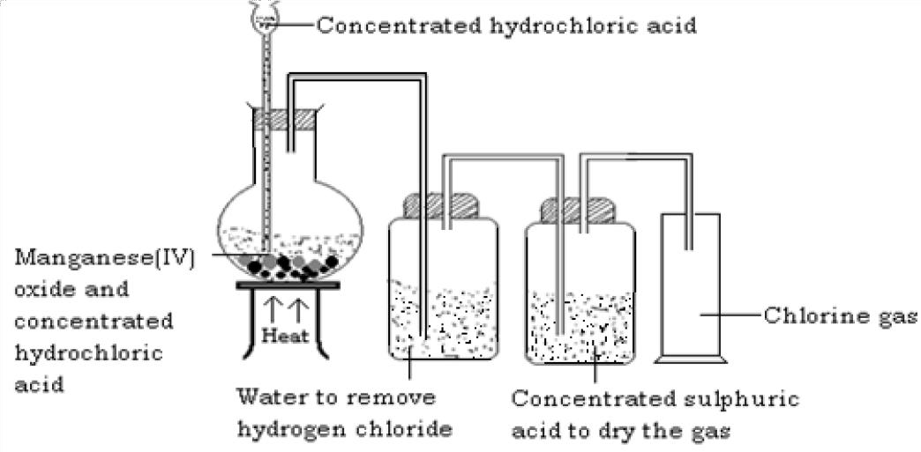

**Observation**

Effervescence occurs evolving a greenish yellow gas (chlorine gas). Chlorine is evolved together with a small amount of hydrogen chloride gas (misty fumes) which is removed by passing it through the first bottle containing water.

The gas is then dried using concentrated sulphuric acid and collected by down ward delivery method since it is denser than air.

Equation

MnO2(s) + 4HCl(aq) MnCl2(aq) + 2H2O(l) + Cl2(g)

Chlorine being a poisonous gas, it is prepared in the fume cupboard.

**Preparation of chlorine from hydrochloric acid by oxidation with potassium permanganate**

**Procedure**

* + Place solid potassium permanganate in a flask
  + Fit the apparatus as shown below

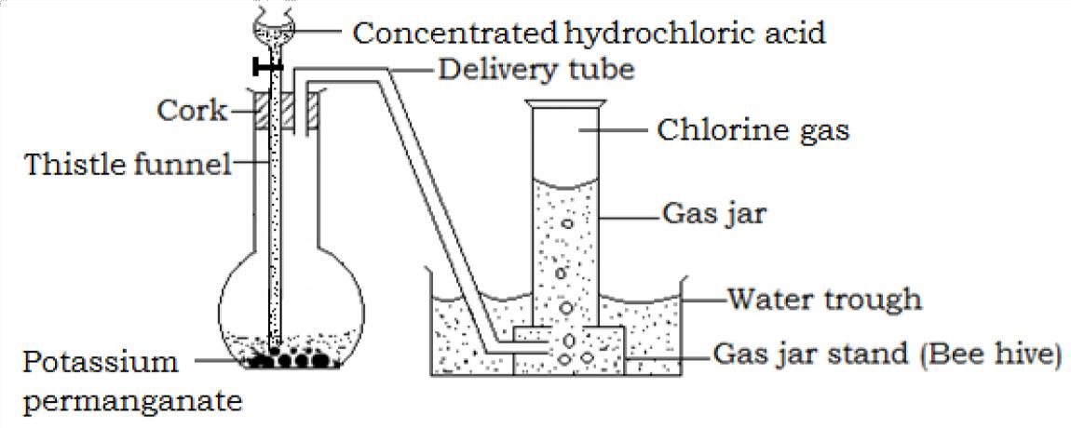

* + Drop on the potassium permanganate concentrated hydrochloric acid from the tap funnel. As each drop reaches the Manganese(IV) oxide, a corresponding quantity of chlorine, a greenish yellow gas is evolved.

Equation

2KMnO4(aq) + 16HCl(aq) 2KCl(aq) + 8H2O(l) + 2MnCl2(aq) + 5Cl2(g)

The gas collection is by down ward deliver of over brine of hot water of in a gas syringe.

This is the most convenient laboratory method because of the following reasons:

* + It does not require heating
  + Rate of production of chlorine can be regulated
  + If the gas is collected over brine, the experiment can be done out of the fume chamber

Chlorine can be prepared from sodium chloride by adding concentrated sulphuric acid to an intimate mixture of sodium chloride and Manganese(IV) oxide. Traces of hydrogen chloride produced are removed by passing the gas over water. The gas is dried and collected by down ward delivery method.

2NaCl(s) + MnO2(s) + 2H2SO4(aq) Na2SO4(aq) + MnSO4(aq) + 2H2O(l) + Cl2(g)

Chlorine can also be prepared from bleaching powder. The bleaching powder is placed in a flask and a dilute acid e.g. nitric acid, hydrochloric acid is added to the powder. Effervescence occurs as a greenish yellow gas (chlorine gas) is evolved. The gas is then dried and collected by any of the methods discussed.

CaOCl2(s) + 2HNO3(aq) Ca(NO3)2(aq) + H2O(l) + Cl2(g)

CaOCl2(s) + 2HCl(aq) CaCl2(aq) + H2O(l) + Cl2(g)

**Industrial manufacture of chlorine**

Chlorine is produced commercially by electrolysis of sodium chloride (brine) solution. Chlorine is evolved at the anode of a specially designed cell, and since the other electrode product (sodium hydroxide, at the cathode) reacts with chlorine, they must be kept apart. This is effected by a circulating mercury diaphragm.

When current is passed through the electrolyte, decomposition takes place as follows.

NaCl (aq) (aq) + (aq)



H2O(l) (aq) + (aq)

**At the cathode**

Both sodium and hydrogen ions move towards the cathode. Because of the nature of the mercury electrode, it will influence the discharge of sodium ion in preference to hydrogen ions since its discharge requires less energy than the discharge of hydrogen.

(aq) + Na(s)

The sodium formed combines with the mercury to form sodium amalgam. The sodium amalgam encounters water in contact with steel grids on which hydrogen has a very low over voltage. Sodium hydroxide is formed and hydrogen gas is liberated.

Equation

Na/Hg(l) + H2O(l) NaOH(aq)+ H2 (l)+ Hg(l)

**At the anode**

Both chloride and hydroxyl ions move to the anode. Due to the high concentration of the chloride ions, it is discharged in preference to hydroxyl ions, therefore forming chlorine gas at the anode.

(aq) – Cl2(g)

NB. Carbon anode is used as it is relatively inert and not easily attacked by chlorine. Chlorine is very reactive and attacks most metals.

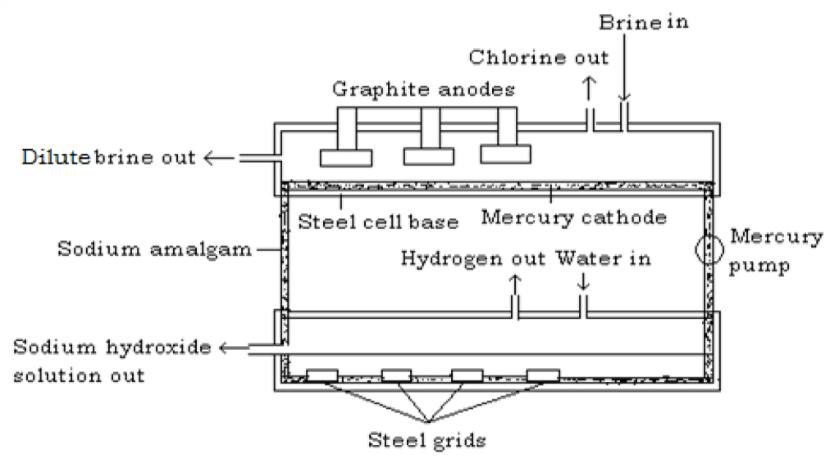

**Properties of chlorine Physical properties**

* + It is a greenish yellow gas with a chocking, unpleasant, irritating smell.
  + It is slightly soluble in water forming a yellowish chlorine water which is a mixture of hydrochloric acid and hypochlorous acid.

H2O(l) + Cl2(g) HOCl(aq) + HCl(aq)

* + It is denser than air.
  + It turns damp blue litmus paper red the bleaches it. Its bleaching action is due to the formation of hypochlorous acid. Dry chlorine does not bleach.
  + Dry Chlorine does not bleach and extinguishes a burning splint.

**Test for chlorine:**

It is a greenish yellow gas which turns moist blue litmus paper red then bleaches it. This is because, the gas is acidic.

**Chemical properties**

1. **Chlorine as a bleaching agent**

Pour a little litmus solution into a gas jar of chlorine.

**Observation:** The litmus immediately turns colourless.

Chlorine bleaches colour from most dyes and will remove colour from writing ink (but not printer‘s ink, which consists mainly of carbon which chlorine does not attack.)

**The bleaching action**

Chlorine reacts with water to form hypochlorous acid H2O(l) + Cl2(g)HOCl(aq) + HCl(aq)

The hypochlorous acid is a very reactive compound and readily gives up its oxygen to the dye, to form a colourless compound.

Dye + HOCl HCl(aq) + (Dye + O)

(Coloured) (Colourless)

The hypochlorous acid turns the coloured dye to colourless by **oxidation** reaction since it gives up its oxygen to the coloured dye.

This indicates that dry chlorine will not bleach since there will be no hypochlorous acid formed.

Hypochlorous acid is also used to kill bacteria and germs in drinking water, swimming pools and in sewage treatment.

1. **Effect of sunlight on chlorine water**

Pass chlorine gas into water in a beaker until water becomes yellow green in colour

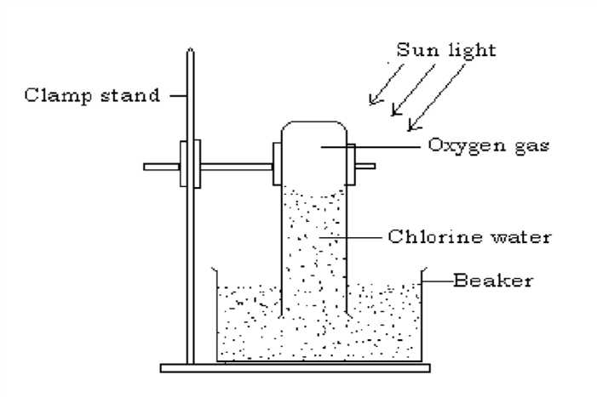i.e. chlorine water is formed. Fill a long tube with this chlorine water and invert it in a beaker containing some of the water and expose it to bright sunlight.

After some times, a gas collects in the tube and on applying a glowing splint, the gas rekindled it showing that the gas is oxygen.

Equation

2Cl2(g) + 2H2O(aq) 4HCl(aq) + O2(g)

The above reaction occurs instantaneously in two stages as H2O(l) + Cl2(g)HOCl(aq) + HCl(aq)

2HOCl(aq) HCl(aq) + O2(g)

1. **Action of chlorine on alkali**
   1. **On cold dilute alkaline solution**

Chlorine reacts with dilute aqueous solution of sodium and potassium forming pale yellow solution of the hypochlorite and chloride of the metal.

Cl2(g) + 2NaOH(aq) NaOCl(aq) + NaCl(aq) + H2O(l)

(Sodium hypochlorite) (Sodium chloride)

Cl2(g) + 2KOH(aq) KOCl(aq) + KCl(aq) + H2O(l)

(Potassium hypochlorite) (Potassium

chloride)

Ionically

Cl2(g) + (aq) (aq) + (aq) + H2O(l)

* 1. **On hot concentrated aqueous solution**

If chlorine is passed into a hot concentrated solution of potassium, a mixture of potassium chlorate and potassium chloride are formed. A similar reaction occurs when chlorine reacts with concentrated sodium and calcium hydroxide.

6KOH(aq) + 3Cl2(g) KClO3(aq) + 5KCl(aq) + 3H2O(l)

Or

3Cl2(g) + (aq) (aq)+ (aq) + 3H2O(l)

1. **Reaction of chlorine with hydrogen**

When a jet of burning hydrogen is lowered into a gas jar of chlorine, it continuous to burn with a white flame producing steamy fumes of hydrogen chloride and the greenish yellow colour of chlorine disappears.

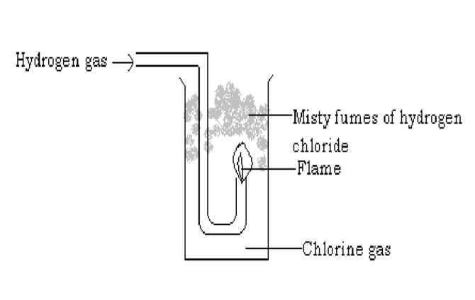

2HCl(g)

H2(g) + Cl2(g)

A mixture of hydrogen and chlorine also explodes when exposed to bright sunlight. This shows the great affinity of chlorine for hydrogen. The reaction is slow in dim sun light and reaction does not take place in the absence of light.

1. **Chlorine as an oxidizing agent**

An oxidizing agent is one which can

1. Remove hydrogen from a compound ii) Accept electrons donated by metals

Chlorine removes hydrogen from many compounds as well as accepts electrons from metals. The oxidizing property of chlorine is illustrated by the following reactions. **i) Reaction with hydrogen sulphide**

When a gas jar of hydrogen sulphide is inverted over a gas jar of chlorine, yellow solids of sulphur and white fumes of hydrogen chloride are formed.

H2S(g) + Cl2(g) 2HCl(g) + S(s)

Hydrogen sulphide has been oxidized to sulphur and chlorine itself was reduced to hydrogen sulphide.

The reaction proceeds as follows

H2S + 

S + (oxidation)



Cl2 + (reduction)

1. **Reaction with ammonia**

Ammonia burns in chlorine and is oxidized to nitrogen and chlorine itself is reduced to hydrogen chloride.

2NH3(g) + 3Cl2(g) N2(g) + 6HCl(g)

The hydrogen chloride produced reacts with excess ammonia forming white fumes of ammonium chloride.

NH3(g) + HCl(g) NH4Cl(s)

Overall equation for the reaction is

8NH3(g) + 3Cl2(g) N2(g) + 6NH4Cl(s)

1. **Oxidation of iron(II) to iron(III)**

Chlorine accepts electrons like other oxidizing agents and is converted to chlorine ion.

Cl2 +

The electron that the chlorine accepts is supplied by a reducing agent which in this case is iron(II).

+ e-

When chlorine gas is bubbled through a pale green solution of iron(II) chloride, it changes to yellow due to the formation of iron(III) chloride. When sodium hydroxide is added to this solution it forms red brown precipitates. This indicates that iron(II) chloride has been oxidized to iron(III) chloride.

2FeCl2(aq) + Cl2(g) 2FeCl3 Or

(aq) + Cl2(g) (aq) + (aq)



1. **Reaction of chlorine with hydrocarbons e.g. turpentine** (C10H16) Hydrocarbons consist of only carbon and hydrogen. Chlorine removes hydrogen from hydrocarbon to form hydrogen chloride and black carbon particles are left.

**Procedure**

Warm a little turpentine in a dish. Dip into it a filter paper and drop the filter paper with turpentine in a gas jar containing chlorine

**Observation**

A red flash accompanied by a violent reaction occurs. Black cloud of solid particles of carbon is produced and hydrogen chloride gas is also formed.

C10H16(l) + 8Cl2(g) 10C(s) + 16HCl(g)

The presence of hydrogen chloride can be shown by blowing the fumes from ammonia bottle across the top of the jar. Dense white fumes of ammonium chloride are formed.

NH3(g) + HCl(g) NH4Cl(s)

1. **Displacement reaction of chlorine**

Chlorine being more reactive than the other halogens displaces them from their salts.

* 1. **Reaction of chlorine with potassium bromide**

When chlorine is bubbled through a saturated solution of potassium bromide, the clear solution immediately turns red (due to formation of bromine water) and a drop of a red liquid (bromine) is observed at the bottom of the boiling tube.

2KBr(aq) + Cl2(g) 2KCl(aq) + Br2(l)

Ionically

(aq) + Cl2(g) (aq) + Br2(l)

Bromine dissolves in tetra chloromethane to form a reddish brown solution.

* 1. **Displacement of iodine**

When chlorine is bubble through a solution of potassium iodide, the clear solution turns to the characteristic dark brown ―iodine‖ colour and a black solid (iodine) is deposited as iodine is only slightly soluble in water. On warming the solution, the characteristic violet vapour of iodine is seen.

2KI(aq) + Cl2(g) 2KCl(aq) + I2(l)

Ionically

(aq) + Cl2(g) (aq) + I2(l)



Iodine dissolves in tetra chloromethane to form a violet solution.

1. **Reaction of chlorine with non-metals**
   1. **Phosphorus**

When a piece of dry yellow phosphorus is lowered in a gas jar of chlorine, it burns spontaneously giving off white fumes of chlorides of phosphorus mainly phosphorus tri chloride (PCl3)

P4(s) + 6Cl2(g) 4PCl3(g)

(Phosphorus(III)

chloride)

P4(s) +10Cl2(g) 4PCl5(g)

(Phosphorus(V) chloride)

* 1. **Sulphur**

When dry chlorine is passed over molten sulphur in a distilling flask, connected to a condenser, a reddish liquid distills over.

2S(l) + Cl2(g) S2Cl2(l)

(disulphur

dichloride)

1. **Reaction of chlorine with metals**
   1. **Reaction with sodium and magnesium**

Burning sodium and magnesium continue to burn is chlorine forming white fumes of sodium and magnesium chlorides respectively.

2Na(s) + Cl2(g) 2NaCl(s)

Mg(s) + Cl2(g) MgCl2(s)

* 1. **Reaction with Dutch metal**

Dutch metal is an alloy of copper and zinc. When a piece of Dutch metal is dropped in a gas jar of chlorine and heated, it burns with a green flame to form copper(II) chloride and Zinc chloride.

Cu(s) + Cl2(g) CuCl2(s) Zn(s) + Cl2(g) ZnCl2(s)

* 1. **Action of chlorine on iron (preparation of iron(III) chloride by direct synthesis)**

**Procedure**

* 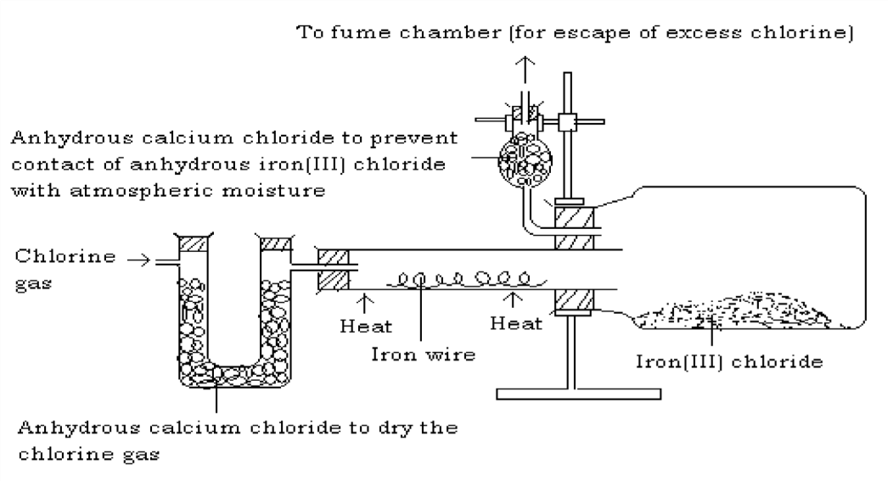Place a coil of iron wire in a hard glass tube in the apparatus below. The iron coil must be free of rust.
* Pass a stream of dry chlorine over it.
* Heat the wire and stop the heating the moment the reaction starts.

**Observation**

The wire glows and the reaction continues without application of heat indicating that the reaction is **exothermic.** Black crystals of iron(III) chloride sublimes and collects in the small bottle which acts as a condenser.

2Fe(s) + 3Cl2(g) 2FeCl3(s)

Formation of iron(III) chloride shows that chlorine is an oxidizing agent. The iron (II) chloride formed is immediately oxidized to iron(III) chloride.

The black crystals of anhydrous iron(III) chloride should be placed in a desiccator as they are very deliquescent.

Note

1. Sodium chloride can be made in a similar way.

2Na(s) +Cl2(g) NaCl(s)

1. Iron(II) chloride (white solid) is made in the same way using dry hydrogen chloride instead of chlorine.

Fe(s) + 2HCl(g) FeCl2(s) + H2(g)

**Uses of chlorine**

1. Chlorine is extensively used as a bleaching agent and in the manufacture of bleaching agents.
2. It is used for making domestic antiseptic solutions such as sodium hypochlorite.
3. Chlorine is used in the manufacture of chlorates used for example as weed killers.
4. Manufacture of hydrogen chloride which is used in the manufacture of plastic like PVC (polyvinylchloride).
5. Manufacture of many organic chemicals e.g. tetra chloromethane (CCl4), 1,1,2trichloroethene (C2HCl3). These compounds are solvents used to remove grease from other substances (degreasing agents), dry cleaning fluids.
6. Chlorine is used to sterilize water for domestic and industrial uses i.e. it kills bacteria and other germs in water and is used in water purification process.

**HYDROGEN CHLORIDE**

**Laboratory preparation**

Hydrogen chloride can be prepared in the laboratory by the action of concentrated sulphuric acid on common salt (rock salt).

**Procedure**

* 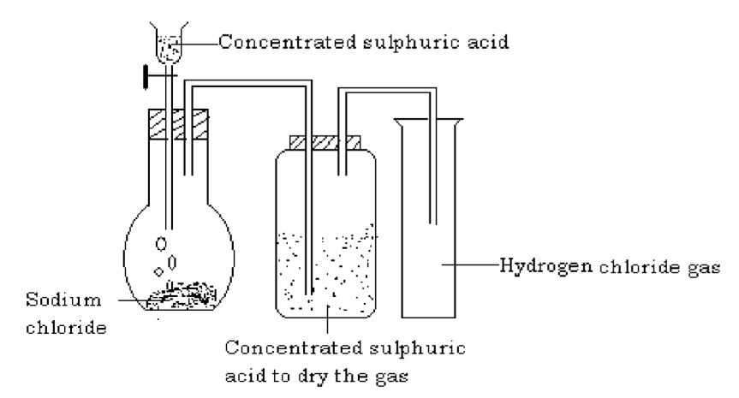Place sodium chloride in flask and fit the apparatus as shown below.
* Add concentrated sulphuric acid down the funnel.

Effervescence occurs and misty fumes are observed. The gas is passed through a wash bottle containing concentrated sulphuric acid to dry the gas and it is collected by down ward delivery method as it is denser than air.

H2SO4(l) + NaCl(s) NaHSO4(s) + HCl(g)

Note

1. Sodium chloride is used because it is cheap and readily available.
2. The reaction proceeds in the cold though a further yield is obtained in the industrial process by heating.
3. The sulphate is not obtained under laboratory conditions because its formation requires a higher temperature but is obtained during the industrial process.

**Test for hydrogen chloride**

* 1. When the gas is bubbled through a solution of silver nitrate and nitric acid, it forms white precipitates of silver chloride.

AgNO3(aq) + HCl(g)AgCl(s) + HNO3(aq) Or

 (aq) + (aq) AgCl(s)

* 1. Hydrogen chloride forms dense white fumes of ammonium chloride with ammonia.

NH3(g) + HCl(g) NH4Cl(s)

**Properties of hydrogen chloride gas Physical properties**

1. It is a colourless gas with an irritating, choking smell.
2. It forms misty fumes in damp air as it forms tiny droplets of hydrochloric acid.
3. It turns moist blue litmus paper red.
4. It is also soluble in methyl benzene (toluene)
5. Hydrogen chloride gas is denser than air.
6. It is very soluble in water. When it dissolves in air, it forms hydrochloric acid.

The high solubility of hydrogen chloride gas in water can be demonstrated by the fountain experiment as that of ammonia.

**Chemical properties**

1. **Deduction of the composition of hydrogen chloride**
   1. **Action of dry hydrogen chloride gas on heated iron**

When dry hydrogen gas is passed over heated iron, the gaseous product that is

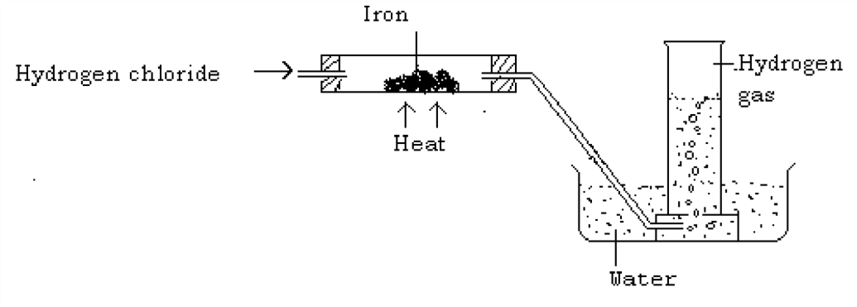collected over wa ter burns with a pop sound indicating that the gas is hydrogen.

Fe(s) + 2HCl(g) FeCl 2 (s) + H 2 (g)

* 1. **Reaction with potassium permanganate (KMnO4)**

When hydrogen chloride gas is slowly passed over potassium permanganate, a greenish yellow gas is formed. The greenish yellow gas is chlorine.

2KMnO4(s) + 16HCl(g) 2KCl(aq) + 2MnCl2(aq) + 8H2O(l) + 5Cl2(g)

From the above two reactions, conclusions can be made that the components of hydrogen chloride are chlorine and hydrogen.

1. **Reaction with ammonia**

Hydrogen chloride reacts with ammonia forming white fumes of ammonium chloride. NH3(g) + HCl(g) NH4Cl(s)

**Preparation of a solution of hydrogen chloride in water (hydrochloric acid)**

The solution of the gas in water forms hydrochloric acid. When the gas is bubbled through water until no more of the gas can dissolve, then the product is concentrated hydrochloric acid and contains 36% by mass of hydrogen chloride.

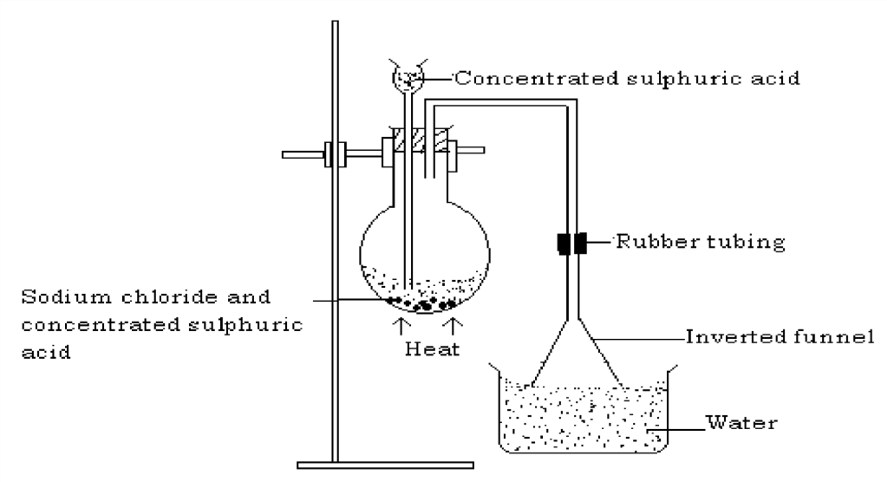When dissolving, the apparatus should be arranged as below. The method is only suitable if the gas is very soluble.

The rim of the funnel must just be at the surface of water in the beaker this avoids water being sucked into the preparation apparatus; a delivery tube cannot also be used because it would suck up water in to the preparation apparatus.

**Properties of hydrochloric acid**

It has all the properties typical of an acid like

* Sour taste
* Turns blue litmus paper red
* It is fully ionized in aqueous solution indicating that it is a strong acid HCl(aq) (aq) +(aq)

H2O(l) + HCl(aq) (aq) + (aq)



* It liberates carbon dioxide with carbonates ZnCO3(s) + 2HCl(aq)ZnCl 2(aq) + CO2(g)+ H2O(l)

Ionically

(aq) + 2 (aq CO2(g)+ H2O(l)

* It forms hydrogen with metals above hydrogen in the electrochemical series.

Mg(s) + 2HCl(aq) MgCl2(aq) + H2(g)

* It neutralizes bases to form salts and water NaOH(aq) + HCl(aq)NaCl(aq) + H 2O(l)

Ionically

(aq) + (aq) H2O(l)

CuO(s) + 2HCl(aq) CuCl2(aq) + H2O(l)

* Oxidizing agents e.g. Manganese (IV) oxide and potassium permanganate oxidize the concentrated hydrochloric acid to chlorine.

2KMnO4(s) + 16HCl(aq) 2KCl(aq) + 2MnCl2(aq) + 8H2O(l) + 5Cl2(g)

These properties are due to the fact that hydrogen chloride although a covalent compound ionizes completely when dissolved in water and therefore show typical acidic characteristics.

**Uses of hydrochloric acid**

* It is used in the removal of rust from iron (descaling) before it is galvanized.
* It is used in cleaning metals before they are electroplated.
* It is used in the manufacture of plastics like polyvinylchloride
* Used in the preparation of soluble chlorides

**Preparation of solution of hydrogen chloride in methyl benzene**

The preparation is done the same way as above. Hydrogen chloride dissolves but does not ionize in organic solvents like methyl benzene and exists as a covalent compound. Therefore, the solution does not conduct electricity; has no effect on litmus paper; does not react with metals above copper and does not react with carbonates or hydrogen carbonates but reacts with ammonia to form white precipitates of ammonium chloride since the salt is insoluble in organic solvents.

**Test for chlorides Solid chlorides**

When concentrated sulphuric acid is added to any chloride, hydrogen chloride gas is evolved.

The gas forms fumes in moist air; turns moist blue litmus paper red; and forms thick white fumes of ammonium chloride with ammonia; and forms white precipitates of silver chloride with acidified silver nitrate solution.

**Chloride in solution**

To a solution of chloride, add a little nitric acid and then silver nitrate solution. White precipitates of silver chloride are seen.

 (aq) + (aq) AgCl(s)

When a little ammonia solution is added to the above solution, the white precipitates dissolve. The precipitates are insoluble in nitric acid. The only two insoluble chlorides are lead(II) chloride and silver chloride.

*Sample questions on Chlorine and its compound*

1. *Describe and explain the laboratory preparation and manufacture of chlorine. Using equations, describe the reactions of chlorine with: metals, non-metals, water, dilute acids and hydrocarbons. How would you show experimentally that hydrogen chloride is very soluble in water? Outline the uses of chlorine.*
2. *With the aid of a labeled drawing, explain how hydrogen chloride and hydrochloric acid are prepared in the laboratory. Describe experiments to deduce the composition of hydrogen chloride. Describe the reactions of hydrogen chloride with ammonia. Explain the behaviour of hydrogen chloride in (i) water and (ii) methyl benzene.*
3. *Describe one experiment in each case to show (a) how hydrochloric acid acts as a reducing agent (b) how hydrogen chloride can be identified. Give the uses of hydrochloric acid.*

# **SULPHUR AND ITS COMPOUNDS**

Sulphur is in period 3 and group VI of the periodic table. It has atomic number number 16 and electronic configuration 2.8.6.

**Occurrence**

It occurs in both Free State and combined state. In the free state it occurs in underground deposits and it is widely distributed in volcanic regions. In combined states it occurs as sulphates, sulphides (mainly hydrogen sulphide) and sulphite. It also occurs in crude oil.

**Extraction of sulpur**

Sulphur is found deep below the ground (160-200) metres, this makes mining it impossible. It is extracted by a method invented by a man called Frasch and the method is **Frasch process**. Sulphur is extracted from the underground deposits by this method basing on its low melting point.

**The Frasch process**

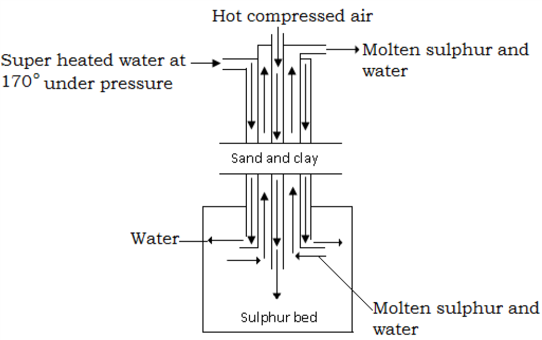

**Procedure**

1. Drill the Frasch pump consisting of three concentric pipes down the sulphur deposit.
2. Super heated water (steam) at about 170˚C is then forced down the outer most tube to melt the sulphur.
3. A jet of hot compressed air is then pumped down through the inner most tube. This hot compressed air pumps the molten sulphur out through the middle tube to the surface where the sulphur is cooled and solidified. The sulphur obtained is about 99.5% pure and can be used directly. It is usually sold in two forms either as ―flowers of sulphur‖ a powder or ―roll sulphur‖, cylindrical sticks.

**Sulphur from natural gas and petroleum**

Natural gas obtained during the distillation of petroleum contains hydrogen sulphide. The hydrogen sulphide can be removed by dissolving it in a suitable solvent. The gas is removed from the solvent and one third (1/3) of the hydrogen sulphide obtained is burnt in oxygen to form sulphurdioxide.

2H2S(g) + 3O2(g) 2H2O(l) +2SO2(g)

The sulphurdioxide reacts with the two third (2/3) of the hydrogen sulphide left to form sulphur.

SO2(g) + H2S(g) S(s) + H2O(l)

The water is evaporated to leave sulphur solids.

**Physical properties of sulphur**

* 1. It is a yellow solid at room temperature
  2. It is a typical non metal
  3. It is insoluble in water but soluble in some organic solvents e.g. methyl benzene and carbon disulphide

**Allotropes of sulphur**

Sulphur has two major crystalline forms .i.e. allotropes namely

1. **Rhombic sulphur (alpha sulphur, α-sulphur)**

Rhombic is an octahedral crystal; its bright yellow in color; its melting point is 114˚C; it has a density of 2.8g/cm3 and it is stable at a temperature below 96˚C.

**Structure**

#### Formation of rhombic sulphur

Shake some powdered sulphur with carbon disulphide for some time in a test tube. (Take care to extinguish all flames from the vicinity).

Filter the content of the test tube into a dry beaker through a dry filter paper and funnelover the mouth of the beaker; fasten a filter paper over the mouth of the beaker and pierce a few pin holes in it, and set the beaker aside.

The carbon disulphide will slowly evaporate depositing crystals of rhombic sulphurwhich because of the slow evaporation will be large enough for their shape to be seen.

NB The formation of the crystal takes place at room temperature.

1. **Monoclinic sulphur (Beta sulphur,β-sulphur)**

It is a needle shaped crystal (prismatic); it is very pale yellow in color (almost transparent); it has a melting point of 119˚C; it has a density of 1.98 g/cm3; it is stable above 96˚C, below 96˚C it reverts to rhombic sulphur.

**Formation of monoclinic sulphur Structure**

Place powdered sulphur in a very large crucible. Heat it and stir gradually while adding some sulphur

until the crucible is full of molten sulphur. Use a small flame for heating otherwise the sulphur will burn.

Allow the sulphur to cool. After some time, a solid crust begins to form on the surface.

When the crust has formed make two holes (at wide separation) using a glass rod on it and pour out the molten sulphur from inside which has not crystallized.

Remove the crust and observe needle shaped crystals of monoclinic sulphur formed beneath the crust and through out the inner surface of the crucible.

**Transition temperature** is a temperature at which rhombic sulphur changes to monoclinic sulphur and vice versa. At a temperature below 96˚C, rhombic sulphur exists and as the temperature goes above 96˚C, the rhombic sulphur changes to monoclinic form. The transition temperature is there fore 96˚C.

**To show that both rhombic and monoclinic sulphur are allotropes of sulphur** When the same mass of either rhombic or monoclinic sulphur is burnt in oxygen, the same mass of sulphur dioxide is obtained in each case and nothing else.

**Other forms of sulphur Amorphous sulphur**

This is a non crystalline form of sulphur which is insoluble in carbon disulphide(CS2). It is formed as an almost insoluble powder if a saturated solution of hydrogen sulphide is oxidized by leaving it to stand in open air for some times i.e.

2H2S(aq) + O2(g) 2S(s) +2H2O(l)

(From air) (Amorhous sulphur)

**Plastic sulphur**

If sulphur at its boiling point is poured into cold water, a dark-sticky (elastic) solid called plastic sulphur is formed. Plastic sulphur is elastic because it contains zig-zag (entangled) chains of S8 molecules.

**N.B** Plastic sulphur is unstable and slowly hardens to form yellow rhombic sulphur. Plastic sulphur is not a separate allotrope of sulphur since it is not crystalline in nature.

**Action of heat on sulphur**

Sulpur under goes a series of changes when it is heated. Both rhombic and monoclinic sulphur consist of S8 molecules with different arrangements. It is this differences in arrangement of sulphur atoms that is responsible for the different observations made when sulphur is heated.

1. If yellow powdered sulphur is heated in the absence of air just above the melting point (about 115˚C), it melts into a clear amber (pale yellow) mobile liquid. This liquid is mobile because the sulphur-8 (S8) molecule rings can flow over one another with ease.
2. On further heating (to about 160˚C), the yellow liquid becomes darker and very viscous. This is because the S8 rings are broken and form long chains of sulphur 8 (S8) atoms. The liquid is viscous because the long chains entangle with one another and thus do not flow readily over each

other. Above 160˚C the darker viscous sulphur liquid becomes mobile and reddish brown in color.

1. Near its boiling point (444˚C), the liquid now becomes lighter in color, thin and more mobile (less viscous). This is because the long entangled chains break down forming chains of S1 and S2 atoms which can flow more readily.
2. The sulphur eventually boils at 444˚C and forms a light brown sulphur vapor.

**Other properties of sulphur**

1. It is a reactive element and it combines directly with other elements (metals and non metals)
   1. If a piece of burning sulphur is lowered into a gas jar of oxygen, it continues to burn even more brightly with a blue flame forming whites fumes with a choking smell. The white fumes with a choking smell are a mixture of white sulphur trioxide and colorless sulphur dioxide gases.

S(s) + O2(g) SO2(g)

2S(s) + 3O2(g) 2SO3(g)

* 1. If mixture of iron dust (iron fillings) and powdered sulphur is heated in a hard glass test tube, the two elements combine vigorously and a spontaneous red glow spreads through the mixture since the reaction is exothermic. A dark grey (black) hard mass of iron(II)sulphide is formed.

Fe(s) + S(s)FeS(s) +heat Almost all sulphides are black.

* 1. Zinc reacts more vigorously with sulphur if the mixture is heated forming zinc sulphide.

Zn(s) + S(s) ZnS(s)

* 1. Hot copper foil (wire) also glows in sulphur vapor forming copper(I) sulphide.

2Cu(s) + S(g) Cu2S(s)

* 1. Carbon combines directly with sulphur to form a liquid, carbon disulphide. Very high temperatures are required for this reaction to occur.

C(s) + 2S(s) CS2(l)

* 1. Reaction with acids

Dilute acids have no effects on sulphur. However,

* + 1. Hot concentrated sulphuric acid oxidizes sulphur to sulphur dioxide and the sulphuric acid its self is also reduced to sulphur dioxide.

S(s) + 2H2SO4(aq) 3SO2(g) + 2H2O(l)

* + 1. Hot concentrated nitric acid oxidises sulphur to sulphuric acid and brown fumes of nitrogen dioxide is given off.

6HNO3(aq) + S(s) 6NO2(s) + H2SO4(aq) +2H2O(l)

**Uses of sulphur**

1. It is used in the making of matches, gun powder and fireworks.
2. Used in the vulcanization (hardening) of rubber
3. Used in the manufacture of sulphuric acid in the contact process.
4. Used as a fungicide and in medicine, ointments and drugs used for the treatment of skin diseases. e.g. Sulphonamide.
5. Used in the production of calcium hydrogen sulphite,Ca(HSO3)2 that acts as a bleaching agent in the wood pulp in manufacture of paper.
6. Sulphur is used in the manufacture of various compounds like carbon disulphide (CS2) and sodium thiosulphide Na2S2O3 used in photography.
7. Fruit trees are sprayed with sulphur products like carbon disulphide (CS2) to kill insects and fungi which cause diseases.

# **COMPOUNDS OF SULPHUR HYDROGEN SULPHIDE (H2S)**

**Laboratory preparation**

It can be prepared in a laboratory by the action of dilute hydrochloric acid or dilute sulphuric acid on iron(II) suphide. The preparation must be done in a fume cupboard as hydrogen sulphide gas is very poisonous.

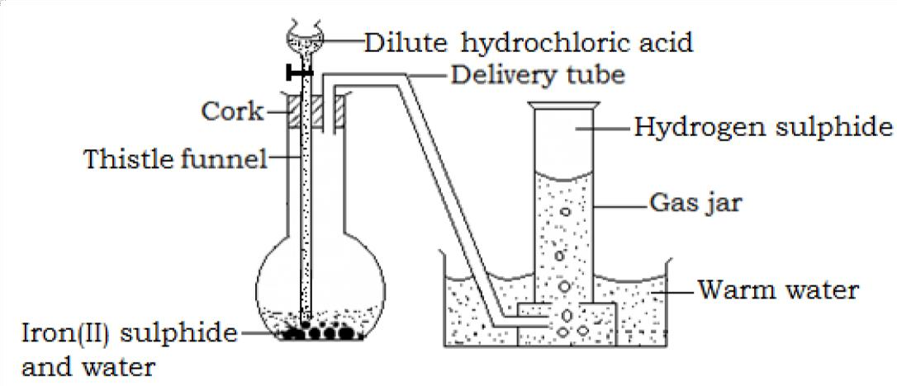**Set up of apparatus**

As the acid reaches the iron (II)sulphide, effervescence begins and the hydrogen sulphide is collected over warm water since in is soluble in cold water. If it is required dry, the gas is passed over anhydrous calcium chloride and then collected by downward delivery method.

Equation

FeS(s) + 2HCl(aq) H2S(g) + FeCl2(aq)

Dilute sulphuric acid may also be used

FeS(s) + H2SO4(aq) H2S(g) + FeSO4(aq)

**NB**

1. Concentrated sulphuric acid is never used to dry the hydrogen sulphide as it reacts with the gas.

(3H2S(g) + H2SO4(aq) 4S(s) +4H2O(l))

1. The hydrogen sulphide prepared in this case contains some impurities especially hydrogen chloride gas and hydrogen.

**Physical properties**

1. It has a strong repulsive characteristic of a rotten egg smell
2. It is a colorless gas
3. It is very poisonous but not as dangerous as carbon monoxide iv) It is slightly denser than air that is why it is collected by downward delivery
4. It can be liquefied under high pressure
5. It dissolves in cold water forming a fairly weak acidic solution

H2S(s) + (aq) H2S(aq)

The weak acid formed dissociates forming ions H2S(aq) (aq) + (aq)

**Test for hydrogen sulphide**

* 1. Hydrogen sulphide can easily be detected by its strong repulsive smell of rotten eggs.
  2. When hydrogen sulphide is passed through a solution of Lead(II)nitrate or Lead(II)ethanoate, a black precipitate of lead(II)sulphide is observed.

(aq) + (aq) PbS(s)

i.e.

With Lead(II)nitrate

Pb(NO3)2(aq) + H2S(g) PbS(s) + 2HNO3(aq)

With Lead(II)ethanoate

(CH3COO)2Pb(aq) + H2S(g) PbS(s) + 2CH3COOH(aq)

**Chemical properties of hydrogen sulphide**

1. Hydrogen sulphide burns in excess air (oxygen) with a pale blue flame forming suphur dioxide and water vapor.

2H2S(g) + 3O2(g) 2SO2(g) + 2H2O(g)

However, in limited supply of air, a yellow deposit of sulphur is formed. 2H2S(g) + O2(g)2S(s) + 2H 2O(g)

1. Hydrogen sulphide is a powerful reducing agent and it gives up its hydrogen to many compounds which are therefore reduced and hydrogen sulphide itself is oxidized to sulphur. For example
   1. When sulphur dioxide is bubbled through a solution of hydrogen sulphide, a yellow deposit of sulphur appears and water is formed.

2H2S(aq) + SO2(g) 3S(s) + 2H2O(l)

* 1. Hydrogen sulphide reacts with halogens to form hydrogen halides and yellow deposits of sulphur e.g. when hydrogen sulphide is mixed with chlorine gas, a pale yellow deposit of sulphur and white fumes of hydrogen chloride gas are produced.

H2S(g) + Cl2(g) S(s) + 2HCl(g)

When hydrogen sulphide is bubbled through bromine water, the reddish brown bromine water is decolorized and pale yellow precipitate of sulphur appears.

H2S(g) + Br2(l) S(s) + 2HBr(aq)

* 1. When hydrogen sulphide is bubbled through a solution of iron(III)chloride, the solution changes from pale yellow to pale green. This is because hydrogen sulphide reduces iron(III)chloride (the pale yellow solution) to iron(II)chloride (a pale green solution). The hydrogen sulphide itself is oxidized to sulphur which appears as a yellow deposit. Hydrogen chloride gas is also formed which dissolves to form hydrochloric acid.

2FeCl3(aq) + H2S(g) 2FeCl2(aq) + + 2HCl(aq) Or



S(s)

2 (aq) + (aq) 2 (aq) + S(s)



* 1. When hydrogen sulphide is bubbled through a solution of acidified potassium manganate(VII), the solution changes color from purple to colorless and a yellow deposit of sulphur is also formed. This is because, hydrogen sulphide reduces manganate(VII) ions (purple in color) to manganese(II) ions(colorless) and the hydrogen sulphide itself is oxidized to sulphur.

2KMnO4(aq) + 6H2SO4(aq) + 5H2S(g) K2SO4(aq) + 2MnSO4(aq) +5S(s) +8H2O(l)

* 1. When hydrogen sulphide is bubbled through a solution of acidified potassium dichromate(VI) the solution changes from orange to green as a result of reduction of the the dichromate(VI) ions to chromium(III) ions.

2K2Cr2O7(aq)+ 8H2SO4(aq)+ 3H2S(g) 2Cr2(SO4)3(aq) + 2K2SO4(aq) +5S(s) + 7H2O(l)

* 1. Hydrogen sulphide reduces concentrated sulphuric acid according to the following reaction

3H2S(g) + H2SO4(aq) 3S(s) +4H2O(l)

* 1. When hydrogen sulphide is bubbled through concentrated nitric acid, brown fumes of nitrogen dioxide together with a pale yellow precipitate of sulphur are observed.

H2S(g) + 2HNO3(aq) 2NO2(g) + S(s) + 2H2O(l)

1. Hydrogen sulphide gas precipitates insoluble sulphides e.g. it precipitates black copper(II)sulphide from blue copper(II)sulphate solution.

CuSO4(aq) + H2S(g) CuS(s) + H2SO4(aq)

**OXIDES OF SULPHUR**

There are two principle oxides of sulphur namely sulphur dioxide and sulphur trioxide.

**SULPHUR DIOXIDE, SULPHUR (IV) OXIDE, SO2**

**Laboratory preparation**

Sulphur dioxide in the laboratory can be prepared in two ways

* 1. Action of concentrated sulphuric acid on copper metal
  2. By action of dilute sulphuric acid or hydrochloric acid on any sulphite salt e.g sodium sulphite(Na2SO3).

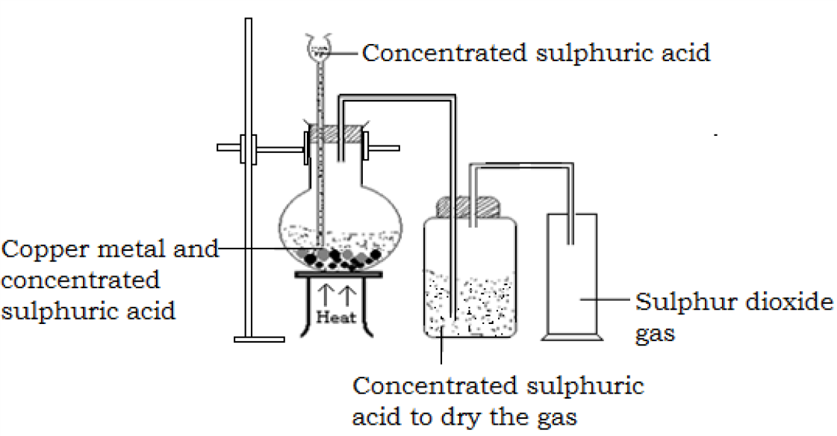**Preparation by the action of concentrated H2SO4 on copper metal**

Place copper metal in the flask and arrange the apparatus as shown above.

Gently heat the mixture until when it is hot. Effervescence occurs as sulphur dioxide is evolved.

Equation

Cu(s) + H2SO4(aq) CuSO4(aq) + SO2(g) + H2O(l)

The gas is passed through a wash bottle containing concentrated sulphuric acid to dry the gas and it is the collected by downward delivery since it is denser than air. The gas is not collected over water as it is very soluble in water.

**Laboratory preparation of sulphur dioxide from sodium sulphite and dilute sulphuric or hydrochloric acid**

The procedure and the arrangement of apparatus remains as shown above but no heating is required for the reaction. However, if the reaction slows down, the flask may be heated gently.

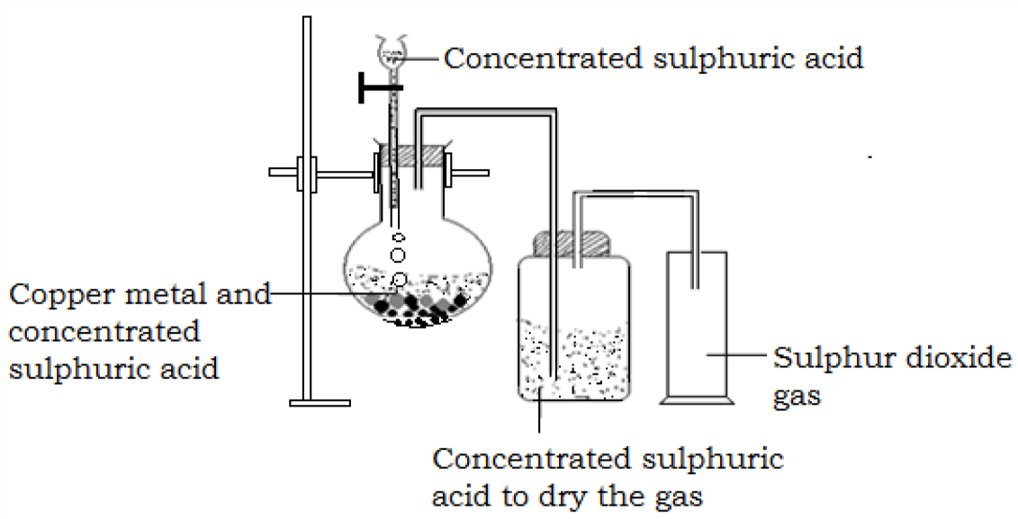

Equation

Na2SO3(s) + 2HCl(aq) SO2(g) + 2NaCl(aq) +H2O(l)

Sodium hydrogen sulphite can also be used under the same conditions. NaHSO3(s) + HCl(aq)SO 2(g) + 2NaCl(aq) +H2O(l)

**Physical properties of sulphur dioxide**

* + 1. It is a poisonous gas
    2. It is a colorless gas with a characteristic pungent smell
    3. It is denser than air
    4. It can easily be liquefied under pressure
    5. It is an acidic gas i.e. it turns moist blue litmus paper red
    6. It is very soluble in water forming sulphurous acid

**Chemical properties of sulphurdioxide**

1. **Reaction with alkalis**

Sulphur dioxide is neutralized by alkalis

* 1. When the alkali is in excess sulphites are formed. 2NaOH(aq) + SO2(g)Na 2SO3(aq) + H2O(l)
  2. When the sulphur dioxide is in excess, hydrogen sulphites are formed and water is not a product in this case.

NaOH(aq) + SO2(g) NaHSO3(aq)

1. **As a reducing agent**

In the presence of water, sulphur dioxide behaves as a reducing agent

1. When sulphur dioxide is bubbled through acidified potassium dichromate(VI) solution, the solution changes from orange to green. This is because, sulphur dioxide reduces chromium (VI) ions to chromium (III) ions.

K2Cr2O7(aq) + H2SO4(aq) + 3SO2(g) Cr2(SO4)3(aq) + K2SO4(aq) + H2O(l)

**NB** This is a characteristic test for sulphurdioxide

1. Sulphur dioxide also reduces acidified potassium Manganate(VII) to manganese (II) sulphate. The color changes from purple to colorless and the sulphur dioxide is itself oxidized to sulphuric acid.

2(aq) +2H2O(aq) + 5SO2(g) 5 (aq) + 2 (aq) + 4 (aq)

This is also used as a test for sulphur dioxide.

1. When sulphur dioxide is bubbled through a solution of iron(III)suphate, the color changes from yellow to pale green. This is because the sulphur dioxide reduces iron (III) sulphate to iron (II) sulphate and the sulphur dioxide is oxidized to sulphuric acid.

Fe2(SO4)3(aq) + 5SO2(g) +2H2O(l) 2FeSO4(aq) + 2H2S04(aq)

1. Sulphur dioxide reduces concentrated nitric acid to form brown fumes of nitrogen dioxide and itself is oxidized to sulphuric acid.

SO2(g) + 2HNO3(aq) 2NO2(g) + H2SO4(aq)

1. Colored solutions of halogen are made colorless when sulphur dioxide is bubbled through them. This is because sulphur dioxide reduces the halogens to hydrogen halides. For example

When sulphur dioxide is bubbled through chlorine water (yellowish green liquid), a mixture of hydrochloric acid and sulphuric acid are obtained which appear colorless.

H2O(l) + SO2(g) + Cl2(g) 2HCl(aq) +H2SO4(aq)

Bromine water (a reddish brown liquid) is turned colorless as bromine is reduced to hydrobromic acid by sulphur dioxide.

H2O(l) + SO2(g) + Br2(g) 2HBr(aq) +H2SO4(aq)

1. **As an oxidizing agent**

Sulphur dioxide acts as an oxidizing agent when it reacts with reducing agents more powerful than itself. Consider the reactions below

1. When sulphurdioxide is bubbled through a solution of hydrogen sulphide, a yellow precipitate is observed. This is because sulphur dioxide oxidizes hydrogen sulphide to yellow sulphur and sulphur dioxide is itself reduced to sulphur.

SO2(g) + 2H2S(aq) 3S(s) + 2H2O(l)

1. When a piece of magnesium ribbon is lowered into a gas jar of sulphur dioxide, it continuous to burn with a bright flame to form white solids (magnesium oxide) and a yellow solid(sulphur). This is because sulphur dioxide oxidizes magnesium to magnesium oxide and itself is reduced to sulphur.

2Mg(s) + SO2(g) 2MgO(s) + S(s)

1. **As a bleaching agent**

Sulphur dioxide bleaches wet flowers like roses and hibiscus and any other wet material by **reduction**. It does this by removing oxygen from the colored material.

Dye + SO2(g) +2H2O(l) + H2SO4(aq)

Dye + H2

Complex appears colourless which

The original color of the bleached material may be restored after prolong exposure to air due to **aerial oxidation**. This explains why old news papers appear yellow after some times.

1. **Reaction with oxygen**

Under normal conditions, sulphur dioxide does not react with oxygen. However when a mixture of dry and pure sulphur dioxide and oxygen is passed over heated platinum catalyst (or vanadium(V)oxide), sulphur trioxide gas is formed.

2SO2(g) O2(g) 2SO3(g)

1. **As an acid anhydride**

Sulphur dioxide is an acid anhydride, reacting with water to form sulphurous acid. SO2(g) + H2O(l) H2SO3(aq)

Sulphurous acid is a dibasic acid and reacts with sodium hydroxide solution to form two salts of sodium, the acid salt;sodium hydrogen sulphite (NaHSO3)and the normal salt;sodium sulphite (Na2SO3)

NaOH(aq) + H2SO3(aq)NaHSO 3(aq) + H2O(l) 2NaOH(aq) + H2SO3(aq) Na2SO3(aq) + 2H2O(l)

**Uses of sulphur dioxide**

1. It is used in the manufacture of sulphuric acid by contact process.
2. It is a poisonous gas and it is used in fumigation to kill germs in clothes and houses.
3. It is used for preservation of food staff and fruits during transportation and storage, as it prevents fermentation.
4. It is used as a bleaching agent e.g it is used to make calcium hydrogen sulphite (Ca(HSO3)2) that makes wood pulp white in paper manufacture, used to bleach silk, straw e.t.c.

**Sulphites ()**

These are salts derived from sulphurous acid.

**Test for sulphite Procedure**

To a solution of substance containing sulphite, add 3 drops of barium nitrate solution followed by excess nitric acid. (or add barium chloride solution followed by excess hydrochloric acid)

**Observation**

White precipitates immediately appear which dissolve with effervescence on adding dilute nitric acid.

(aq) + (aq) BaSO3(s) On addition of nitric acid

BaSO3(s) + HNO3(aq) Ba(NO3)2(aq) + SO2(g) + H2O(l)

**SULPHUR TRIOXIDE (SO3)**

**Laboratory preparation**

It can be prepared in the laboratory by passing a dry mixture of oxygen and sulphur dioxide over a heated platinum catalyst or (Platinized asbestos) at a temperature of 450-500˚C.

**Set up of apparatus**

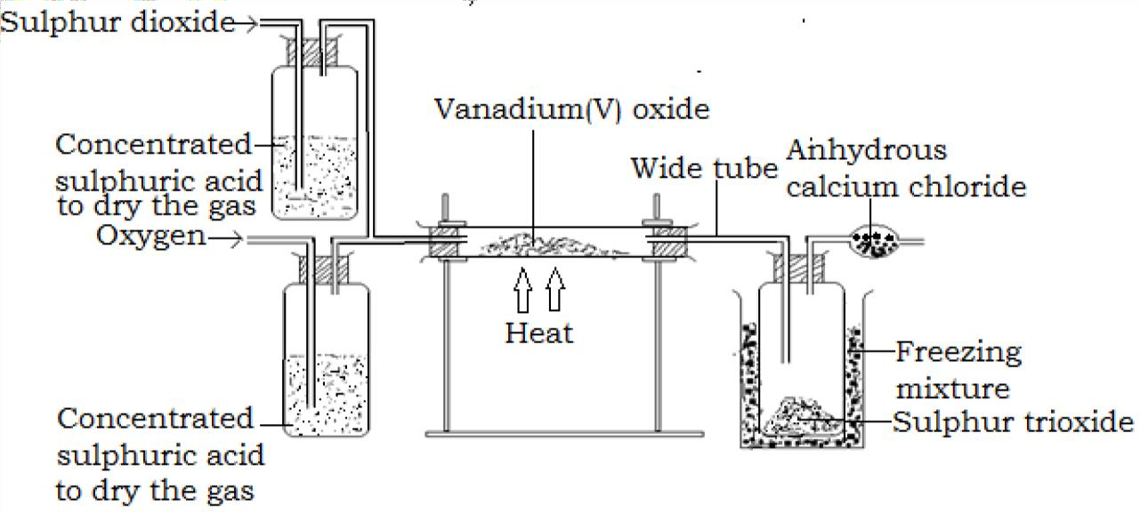

**Equation for the reaction**

2SO2(g) + O2(g) 2SO3(g)

The sulphur trioxide is seen as dense white fumes and may be solidified in a freezing mixture of ice and a little sodium chloride. The sulphur trioxide container is protected from atmospheric moisture by calcium chloride tube.

**Properties of sulphur trioxide**

1. It has very high affinity for water and combines with it violently forming sulphuric acid.

SO3(g) + H2O(l) H2SO4(aq)

This reaction is highly exothermic i.e. it gives out a lot of heat and it is because of this that sulphur trioxide is kept in air tight containers.

1. Sulphur trioxide combines with concentrated sulphuric acid to form fuming sulphuric acid called oleum.

SO3(g) + H2SO4(aq) H2S2O7(l)

**SULPHURIC ACID (H2SO4)**

**Large scale (Industrial) manufactureof sulphuric acid by contact process**

In the manufacture of sulphuric acid by contact process, sulphur dioxide and oxygen are the starting materials.

The sulphur dioxide is oxidized to sulphur trioxide which is then absorbed by concentrated sulphuric acid forming oleum (fuming sulphuric acid) to which water is added to form the sulphuric acid.

This process can be divided into the following essential stages;

1. **Preparation of sulpur dioxide**

Sulpur dioxide can be obtained from the following source;

* 1. Burning sulpur in air. This is cheap and produces sulphur dioxide in large quantities

S(s) + O2(g) SO2(g)

* 1. Roasting sulphide ores in air

4FeS2(s) + 11O2(g) 8SO2(g) + 2Fe2O3(s) (Iron

pyrite)

2ZnS(s) + 3O2(g) 2SO2(g) + 2ZnO(s)

(Zinc blende)

Other sources of sulphur dioxide include; burning of hydrogen sulphide from crude oil in air; flue gas desulphurization in power stations e.t.c.

Oxygen is obtained from fractional distillation of liquid air.

1. **Purification of the gases**

The sulphur dioxide and the oxygen are purified and dried (i.e. cleared off any dust particles and other impurities which can poison the catalyst especially if it is platinum.

1. **Preparation of sulphur trioxide**

The purified gases are passed over a finely divided vanadium (V) oxide,(V2O5) catalyst at a temperature of 450-500C and a pressure of 2-3 atmospheres, sulphur trioxide is formed. Vanadium (V) oxide is commonly used because it is cheaper and not easily poisoned by impurities.

Catalyst (V2O5)

2SO2 (g) + O2 (g) 2SO3 (g)

Temp 450-500 0C

Pressure, 2-3 atm

The catalyst Vanadium (V) oxide is so effective that 95% conversion of sulphur dioxide to sulphur trioxide is achieved at 450-500C and 2 atmospheres. The reaction is exothermic and there fore produces heat enough to maintain the temperature of the catalyst.

1. **Conversion of sulphur trioxide to sulphuric acid**

Sulphur trioxide,SO3 must not be allowed to come in contact with water as the reaction is intensely exothermic that it vaporizes the sulphuric acid formed (i.e. produces a lot of mist consisting of dry droplets of H2SO4 ).

To prevent this happening, the sulphur trioxide, SO3 is absorbed in concentrated sulphuric acid, H2SO4 to form an oily liquid called an Oleum

H2SO4(aq) + SO3(aq) H2S2O7(l)

The oleum produced is carefully diluted to give 95-98% pure concentrated sulphuric acid.

H 2 S 2 O 7 (l) + H 2 O(l) 2H 2 SO 4 (aq )

Summary of the contact process



**Electrostatic**

**precipitator**- removes dust and impurities

**Converter**: V2O5, 450-500˚C, 2 atm.

Sulphur trioxide is SO3

**Sulphuric acid**

**Dilution chamber**- the oleum is diluted with water to form concentrated sulphuric acid

**Absorption chamber**- Conc. H2SO4 absorbs SO3 forming oleum

O2

**Drier**-removes moisture from the gases

SO2

In the above process, the following conditions favor high yield of sulphur trioxide:

* Presence of a catalyst. The catalyst must be finely divided to increase the surface area for the reaction.



* Low temperature(450-500C) as the reaction is exothermic (releases heat),
* Slightly high pressure above the atmospheric pressure as the reaction is accompanied by a decrease in volume.
* High concentration of oxygen or sulphur dioxide.

**Properties of sulphuric acid a) Physical properties**

1. Concentrated Sulphuric acid is a dense, colorless and oily liquid.
2. Concentrated sulphuric acid has very high affinity for water and a lot of heat is produced when the acid is diluted.
3. Concentrated sulphuric acid is hygroscopic. I.e. gradually absorbs moisture from the air and therefore when left exposed to air, in a beaker, the total volume gradually increases due to absorption of water. This is why it is used as a drying agent for many of the gases.
4. **Chemical properties**
   1. **Sulphuric acid as an acid**

It is the dilute sulphuric acid that reacts as a typical acid. i. Dilute sulphuric acid ionizes to form hydrogen ions

H2SO4(aq) H+(aq) + (aq)

* + 1. Sulphuric acid liberates hydrogen gas from reactive metals e.g. Na, Mg, and Ca.

Ca(s) + H2SO4(aq) Ca(OH)2(aq) + H2(g)

* + 1. It reacts with bases to form salt and water only. Since it is a dibasic acid, it produces two types of salts, the normal salt (sulphate) when alkali is in excess and the acidic salt (hydrogen sulphate) when the acid is in excess.

H2SO4(aq) + NaOH(aq) NaHSO4(aq) + 2H2O(l)

H2SO4(aq) + 2NaOH(aq) Na2SO4(aq) + 2H2O(l)

* + 1. It reacts with carbonates and hydrogen carbonates to liberate carbondioxide gas

Na2CO3(aq) + H2SO4(aq)Na 2SO4(aq) + H2O(l) + CO2(g) Ca(HCO3)2(aq) + H2SO4(aq)CaSO 4(aq) + H2O(l) CO2(g)

**NB** With calcium carbonate and lead (II) carbonate, there is little effervescence and the reaction stops soon because the sulphates formed are insoluble and form a coating around the carbonate preventing any further attack by sulphuric acid on the carbonate.

* 1. **As an oxidizing agent**

Hot concentrated sulphuric acid is a powerful oxidizing agent and in all reactions, it is itself reduced to sulphur dioxide. Metals are oxidized to sulphates and non metals to their oxides. Example include:

1. Hot concentrated sulphuric acid oxidizes copper to copper (II) sulphate and the sulphuric acid itself is reduced to sulphur dioxide.

2H2SO4(l) + Cu(s) CuSO4(aq) +SO2(g) +2H2O(l)

1. When charcoal is heated with concentrated sulphuric acid, the charcoal is oxidized to carbon dioxide and the sulphuric acid is reduced to sulphur dioxide.

2H2SO4(l) + C(s) CO2(aq) +2SO2(g) +2H2O(l)

1. Hot concentrated sulphuric acid oxidizes sulphur to sulphur dioxide and the sulphuric acid itself is reduced to sulphur dioxide also.

2H2SO4(l) + S(s) 3SO2(g) +2H2O(l)

1. When a sample of hydrogen sulphide gas is bubbled through concentrated sulphuric acid, the hydrogen sulphide is oxidized to sulphur and the sulphuric acid is reduced to sulphur dioxide.

H2S + H2SO4(l) S(s) + SO2(g) +2H2O(l)

* 1. **As a dehydrating agent**

Concentrated sulphuric acid is a very strong dehydrating agent i.e. it removes the elements of water from many compounds. Examples

1. When concentrated sulphuric acid is added to blue copper (II) sulphate crystals, the copper(II)sulphate crystals gradually become white as their water of crystallization is lost.

CuSO4.5H2O(s) CuSOConcentrated H 2SO4 4(s) + 5H2O(g)

1. When cold concentrated sulphuric acid is added to sugar crystals in an evaporating dish, the sugar crystals turn progressively from white, to yellow then to brown and finally to black. A spongy black mass of charcoal rises almost filling up the dish , water vapor is given off and the dish becomes very hot as the reaction is exothermic (generates energy).

Concentrated H2SO4

C12H22O11(s) 12C(s) + 11H2O(g) + Heat

In this reaction ,the concentrated acid removes the elements of water from sugar leaving a black mass of carbon.

A similar action is the explanation of a very marked corrosive action of the acid on flesh and cloth made of cotton. Cotton is largely cellulose whose simplest formula is (C6H10O5)n.

1. Concentrated sulphuric acid dehydrates oxalic acid on heating to form a mixture of carbon monoxide, carbon dioxide and water.

Concentrated H2SO4

H2C2O4(s) CO(g) + CO2(g) + H2O(l)



1. Excess concentrated sulphuric acid dehydrates ethanol at a temperature of 170C forming ethene.

C2H5OH(l) CConcentrated H 2SO4,170˚C 2H4(g) + H2O(l)

When concentrated sulphuric acid removes elements of water from a compound with the formation of a new compound, it is described as a **dehydrating agent**.

* 1. **As a drying agent**

When concentrated sulphuric acid removes water from a mixture, it acts as a **drying agent**.

Concentrated sulphuric acid reacts exothermically with water. When a solution is made, it is essential to pour the acid into water, stirring to disperse the heat evolved. It is dangerous to add water to concentrated sulphuric acid as small pockets of water are likely to boil.

Gases are dried by bubbling them through concentrated sulphuric acid. For basic gases like ammonia, another drying agent is used.

**Uses of sulphuric acid**

1. Used in the manufacture of fertilizers like ammonium sulphate.
2. Making of paints and pigments
3. Manufacture of detergents and soap
4. Production of other chemicals such as metallic sulphates, hydrochloric acid, hydrofluoric acid and plastics.
5. Extraction of metals and metal manufacturing including pickling to clean metallic surfaces.
6. Extraction of alkenes in petroleum refinery.
7. With nitric acid, it is used to make dyes and explosives.

**Sulphates**

These salts are derived from sulphuric acid.

All sulphates are soluble in water except barium sulphate, lead(II)sulphate and calcium sulphate is slightly soluble in water.

**Action of heat on sulphates**

Most of the sulphates are resistant to heat, but if they are hydrated, they lose their water of crystallization and become powdery upon slight heating. E.g.

Na2SO4.10H2O(s) Na2SO4(s) + 10H2O(l)

However, iron (II) sulphate, copper (II) sulphate, ammonium sulphate and sulphates of other metals lower than copper in the reactivity series are decomposed upon strong heating. For example

1. When a green hydrated solid of iron (II) sulphate is heated gently, it loses its water of crystallization which condenses on the cooler part of the test tube forming dirty yellow anhydrous solids of iron (II) sulphate.

FeSO4.7H2O(s) FeSO4(s) + 7H2O(l)

On further heating, the anhydrous dirty yellow solids decompose giving off sulphur dioxide (which turn orange potassium dichromate green) in addition to white fumes of sulphur trioxide and leave a brown solid of iron (III) oxide.

2FeSO4(s) Fe2O3(s) + SO3(g) + SO2(g)

Overall equation: 2FeSO4.7H2O(s) Fe2O3(s) + 14H2O (l) + SO3(g) +SO2(g)

1. When a blue copper(II)sulphate crystal is heated, it losses its water of crystallization forming white anhydrous powder of copper(II)sulphate.

CuSO4.5H2O(s) CuSO4(s) + 5H2O(l)

On strong heating, the white anhydrous white solid decomposes into white fumes of sulphur trioxide, a colorless gas (sulphur dioxide) and a black solid residue (copper(II)oxide).

2CuSO4(s) 2CuO(s) + SO3(g) + SO2(g)

**Chemical test for sulphates**

To the solution of the suspected sulphate in water, add barium chloride and dilute hydrochloric acid (barium nitrate solution and dilute nitric acid can also be used.) a white precipitate which is insoluble in excess acid indicates the presence of a sulphate.

BaCl2 (aq) + Na2SO4 (aq)BaSO 4(s) + 2NaCl Ionically)

 Ba SO4(s)

*Sulphur and its compounds*

1. *Describe fully the changes which take place when powdered sulphur is gradually heated to its boiling point in the absence of oxygen. Mention briefly the proof that rhombic and monoclinic sulphur are allotropes.*
2. *Describe the large scale extraction of sulphur. Describe the preparation and collection of gas jars of hydrogen sulphide starting from powdered sulphur. Describe an experiment to show the action of this gas as (a) a combustible substance (b) a reducing agent (c) an acid forming salt.*
3. *What is the effect of heat on ferrous sulphate crystals? Make a drawing to show how you can convert sulphur dioxide to sulphur trioxide. What is the action of sulphur dioxide on (a) nitric acid (b) hydrogen sulphide (c) chlorine.*
4. *Explain how sulphuric acid is manufactured on a large scale. Outline four large scale uses of the acid. Describe one experiment in each case to show how sulphuric acid acts as (a) an oxidizing agent (b) a dehydrating agent (c) a bleaching agent*
5. *Give atleast five chemical properties of concentrated sulphuric acid. Why is this acid said to be dibasic? How can sulphates and sulphites be identified in the laboratory.*
6. *Describe the preparation and collection of hydrogen sulphide. Give four chemical properties of the gas. What changes occur when the gas is bubbled through*

*solutions of (a) copper sulphate (b) lead nitrate (c) chlorine. Write equations for the reactions.*

1. *Make a labeled drawing of apparatus you would use to prepare sulphur dioxide. How does this gas react with (a) chlorine water (b) hydrogen sulphide (c) sodium hydroxide solution? How can sulphur dioxide be converted to sulphuric acid?*
2. *Starting with roll sulphur, how can rhombic sulphur crystals, monoclinic sulphur crystals and plastic sulphur are obtained.*

|  |  |  |
| --- | --- | --- |
| **Atoms** | **Relative atomic mass** | **Molar mass** |
| Hydrogen | 1 | 1g |
| Carbon | 12 | 12g |
| Oxygen | 16 | 16g |
| Sodium | 23 | 23g |
| Magnesium | 24 | 24g |
| Sulphur | 32 | 32g |
| Aluminium | 27 | 27g |
| Copper | 64 | 64g |
| Silver | 108 | 108g |
| Lead | 207 | 207g |
| Chlorine | 35.5 | 35.5g |
| Calcium | 40 | 40g |
| Potassium | 39 | 39g |
| Tin | 119 | 119g |
| Zinc | 65 | 65g |
| Nickel | 59 | 59g |
| Nitrogen | 14 | 14g |
| Iron | 56 | 56g |
| Phosphorus | 31 | 31g |

|  |  |  |
| --- | --- | --- |
| **Compound** | **Molecular formula** | **Empirical formula** |
| Water | H2O | H2O |
| Ammonia | NH3 | NH3 |
| Ethene | C2H4 | CH2 |
| Benzene | C6H6 | CH |
| Glucose | C6H12O6 | CH2O |

|  |  |
| --- | --- |
| Mole ratio 1 1.5 | 6 |
| 2x (1 1.5 | 6) |
| 2 3 | 12 |

|  |  |
| --- | --- |
| **Condition** | **Value for molar gas volume** |
| Standard temperature and pressure(stp) | 22.4*l* or 22.4dm3 or 22400cm3 |
| Room temperature and pressure (rtp) | 24*l* or 24dm3 or 24000cm3 |

|  |  |
| --- | --- |
| **Apparatus** | **Use** |
| Pipette | This is used for measuring and transferring fixed volumes of solutions. The volume of solution (usually whose concentration is not known) is measured accurately and transferred into a conical flask using a pipette. The solution transferred by the pipette is the **aliquot**. The common pipettes used are of volumes 20.0cm3 and 25.0cm3 which are usually written on them. The reading of a pipette is recorded to one decimal place e.g.  20.0 cm3. |
| Burette | This is used to transfer accurately a precise volume of solution. The **titrant** is filled into a burette using a filter funnel to prevent wastage of solutions. The reading of a burette is recorded to two decimal places e.g. 0.00cm3, 18.40cm3 e.t.c. For accurate reading of volumes of liquid in burettes and pipettes, the eye must be at the same level with the meniscus of the liquid as illustrated besides. |
| Conical flask | It is a container in which the reaction between the acid and the alkali take place. The titrant is run from a burette into a conical flask containing a known volume of the solution (usually whose concentration is not known). |
| White tile | It enables one to observe indicator color changes more clearly. A piece of white paper can be used in place of a white tile. |
| Filter funnel | Enables the solution to be poured directly into  the burette without wastage |
|  |  |

|  |  |
| --- | --- |
| Dropper | For addition of the indicator to the solution in the conical flask |
| Beaker | For holding and pouring out solutions |

|  |  |  |
| --- | --- | --- |
| **Indicator** | **Color in acidic solution** | **Color in alkaline solution** |
| Phenolphthalein | Colorless | Purple |
| Methyl orange | Red/pink | Yellow |
| Litmus | Red | Blue |

|  |  |  |  |
| --- | --- | --- | --- |
| Number of titration | 1 | 2 | 3 |
| Final burette reading/ cm3 | 14.80 | 30.00 | 15.00 |
| Initial burette reading/ cm3 | 0.00 | 15.00 | 0.00 |
| Volume of acid used/ cm3 | 14.80 | 15.00 | 15.00 |